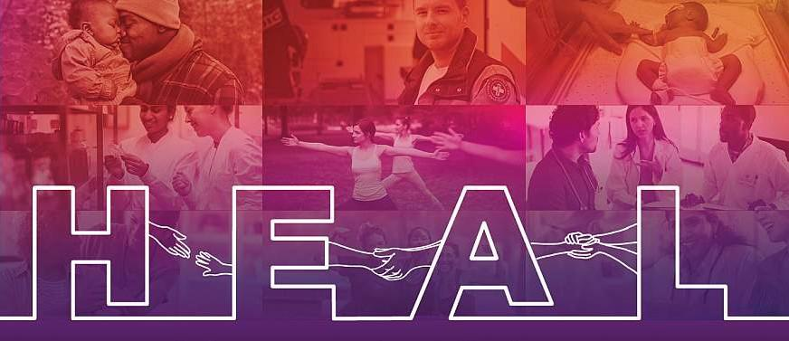

Communities That HEAL

# Phase 2 Video Release ● Social Media Content

## *Wave One, Campaign Four: Stay in MOUD Treatment*

June 21, 2021 - December 31, 2021

**Social Media Content**

**PURPOSE:**

Sample copy for social media posts to accompany the videos and graphics included in the CAMPAIGN 4, PHASE 2 VIDEO RELEASE is provided below. Edit the sample copy as needed to meet the desired social media platform.

**HASHTAGS**:

We encourage you to include hashtags in your posts to increase engagement. Consider including hashtags in each social media post. We recommend 1-2 hashtags on Facebook and 3-5 on Twitter and Instagram.

Possible hashtags include:

# #HealTogetherMA, #SupportMOUD, #YourTreatment, #YourRecovery, #NoStigma, #EndStigma, #MOUDisrealrecovery, #MOUDworks, #Bupeworks, #methadoneworks, #OpioidUseDisorder, #communityname

# Profile Videos

**DIRECTIONS:** Copy and paste the sample copy into the post on the desired platform (e.g., Facebook). Include preferred hashtags above.

**NOTE:** Always include the www.HealTogetherStories.org link in the post copy to direct the target audience to the HCS website for more information on local treatment and recovery resources.

Sample Post Text to Accompany New Profile Videos Available in the Campaign 4, Phase 2 Video Release

## *Brian Profile*

Early recovery was challenging for Brian. He got through it by setting an alarm and taking his medication for opioid use disorder every day. At 27 years old, he has learned to love himself for the first time.

Watch more inspiring stories at [www.youtube.com/HEALingCommunitiesStudy](http://www.youtube.com/HEALingCommunitiesStudy) and learn more about treatment and recovery at [www.HealTogetherStories.org](http://www.HealTogetherStories.org).

[Brian’s Story: <https://youtu.be/9McFe5T72No>]

## *Nick Profile*

Nick started his medication for opioid use disorder treatment journey after a tough phone call with his dad. Nine years later, he is a peer support specialist who inspires others in their recovery. “You have nothing to lose and everything to gain.”

Watch more inspiring stories at [www.youtube.com/HEALingCommunitiesStudy](http://www.youtube.com/HEALingCommunitiesStudy) and learn more about treatment and recovery at [www.HealTogetherStories.org](http://www.HealTogetherStories.org).

[Nick’s Story: <https://youtu.be/CDSUPx0o7mQ>]

## *Scotty Profile*

Scotty used medication to treat his opioid use disorder. Today, he works on his recovery every day and inspires others to do so. “Every day that you do your treatment, work your program, and do what you need to do for your recovery is a miracle.”

Watch more inspiring stories at [www.youtube.com/HEALingCommunitiesStudy](http://www.youtube.com/HEALingCommunitiesStudy) and learn more about treatment and recovery at [www.HealTogetherStories.org](http://www.HealTogetherStories.org).

[Scotty’s Story: <https://youtu.be/IyjPjVll4jM>]

## *Lexa Profile*

Lexa struggled to stop taking opioids cold turkey. Now, she takes medication for opioid use disorder every day, and her whole being has changed. She feels great and has learned ways to cope with life’s challenges without returning to drugs. “It’s worth it.”

Watch more inspiring stories at [www.youtube.com/HEALingCommunitiesStudy](http://www.youtube.com/HEALingCommunitiesStudy) and learn more about treatment and recovery at [www.HealTogetherStories.org](http://www.HealTogetherStories.org).

[Lexa’s Story: <https://youtu.be/0BXr47BZ7FA>]

## *Shannon Profile*

When Shannon began taking a medication called Suboxone® for her opioid use disorder, loved ones shamed her and told her she was not “clean.” She stopped her medication and experienced a relapse. Now, she is back in medication treatment and in long-term recovery. “I am walking proof that you can change, and it does work.”

Watch more inspiring stories at [www.youtube.com/HEALingCommunitiesStudy](http://www.youtube.com/HEALingCommunitiesStudy) and learn more about treatment and recovery at [www.HealTogetherStories.org](http://www.HealTogetherStories.org).

[Shannon’s Story: <https://youtu.be/006XzE7iNNM>]

## *Traci Profile*

Ten years ago, Traci was incarcerated and worried she would not survive. She now takes medication for opioid use disorder daily. She has been on medication and in recovery for two and a half years and works to support others in treatment. “If things are working, why change it?”

Watch more inspiring stories at [www.youtube.com/HEALingCommunitiesStudy](http://www.youtube.com/HEALingCommunitiesStudy) and learn more about treatment and recovery at [www.HealTogetherStories.org](http://www.HealTogetherStories.org).

[Traci’s Story: <https://youtu.be/KQWm0LZ3VLw>]

## *Brittany Profile*

Brittany knew that she needed help but did not think she deserved it. While pregnant and incarcerated, Brittany started methadone treatment for her opioid use disorder. Within a day, she began to feel better and soon realized that recovery was possible. “It’s so important for people to know that there is help. I want people to know that because I did not.”

Watch more inspiring stories at [www.youtube.com/HEALingCommunitiesStudy](http://www.youtube.com/HEALingCommunitiesStudy) and learn more about treatment and recovery at [www.HealTogetherStories.org](http://www.HealTogetherStories.org).

[Brittany’s Story: <https://youtu.be/gnttVQtWjgY>]

## *Jeremy Profile*

A counselor suggested medication for opioid use disorder when Jeremy expressed concerns about cravings and risk of relapse. Buprenorphine helped safeguard him from cravings and led to his long-term recovery. “There are people out there like you. You are not alone.”

Watch more inspiring stories at [www.youtube.com/HEALingCommunitiesStudy](http://www.youtube.com/HEALingCommunitiesStudy) and learn more about treatment and recovery at [www.HealTogetherStories.org](http://www.HealTogetherStories.org).

[Jeremy’s Story: <https://youtu.be/7pgAwwxEKkM>]

## *Johnny Profile*

After his first dose of medication for opioid use disorder, Johnny felt the physical symptoms of withdrawal decrease. Then, he felt the possibilities offered by long-term treatment, recovery, and a better life for him and his family.

Watch more inspiring stories at [www.youtube.com/HEALingCommunitiesStudy](http://www.youtube.com/HEALingCommunitiesStudy) and learn more about treatment and recovery at [www.HealTogetherStories.org](http://www.HealTogetherStories.org).

[Johnny’s Story: <https://youtu.be/I-4FLGcjY-o>]

# New PSAs

**DIRECTIONS:** Copy and paste the sample copy into the post on the desired platform (e.g., Facebook). Links to the two new PSAs are provided below; however, instead of including the link in the post, we highly recommend downloading the PSA file from your toolbox and uploading it into the post.

**NOTE:** Always include the www.HealTogetherStories.org link in the post copy to direct the target audience to the HCS website for more information on local treatment and recovery resources.

[15 second PSA YouTube Video Link – Shannon and Brian: <https://youtu.be/9JgJIH7UfEA>]

[30 second PSA YouTube Video Link – Johnny, Shannon, and Brian: <https://youtu.be/XTOP3w3xI9g>]

## *Post 1*

Staying in medication treatment as long as necessary is the best way to reach goals and enter long-term remission and recovery from opioid use disorder.

Watch more inspiring stories at [www.youtube.com/HEALingCommunitiesStudy](http://www.youtube.com/HEALingCommunitiesStudy) and learn more about treatment and recovery at [www.HealTogetherStories.org](http://www.HealTogetherStories.org).

## *Post 2*

Addiction does not define who you are. Staying on medication is your path to recovery from opioid use disorder.

Watch more inspiring stories at [www.youtube.com/HEALingCommunitiesStudy](http://www.youtube.com/HEALingCommunitiesStudy) and learn more about treatment and recovery at [www.HealTogetherStories.org](http://www.HealTogetherStories.org).

## *Post 3*

Medications for opioid use disorder save (or improve) lives. And it is important to stay in medication treatment as long as needed. Treatment takes time, but it also gives time back.

Watch more inspiring stories at [www.youtube.com/HEALingCommunitiesStudy](http://www.youtube.com/HEALingCommunitiesStudy) and learn more about treatment and recovery at [www.HealTogetherStories.org](http://www.HealTogetherStories.org).

# New Treatment Library Videos

## Sample Post Text to Accompany New Treatment Library Videos Available in the Campaign 4, Phase 2 Video Release

## *Johnny – Friends Who Use Drugs*

Johnny’s tips for staying in medication treatment for opioid use disorder? Avoid people, places, and things that remind you of using drugs, and be honest with yourself and others, especially early in recovery.

Learn more tips at [www.youtube.com/HEALingCommunitiesStudy](http://www.youtube.com/HEALingCommunitiesStudy) and more about treatment and recovery at [www.HealTogetherStories.org](http://www.HealTogetherStories.org).

## [Johnny’s Tips to Manage Triggers: <https://youtu.be/RM3RQ_nH9jU>]

## *Nick – Trouble Sleeping*

## Inhale for four seconds. Hold for seven. Exhale for eight. Watch to learn this and more tips for trouble sleeping while on medication for opioid use disorder. Thanks, Nick!

Learn more tips at [www.youtube.com/HEALingCommunitiesStudy](http://www.youtube.com/HEALingCommunitiesStudy) and more about treatment and recovery at [www.HealTogetherStories.org](http://www.HealTogetherStories.org).

## [Nick’s Tips to Manage Trouble Sleeping: <https://youtu.be/3ghBftrLITE>]

## *Joseph – Anxiety and Depression*

Joseph struggled to manage his anxiety while in medication treatment for #opioidusedisorder. Self-care – including reading, hot baths, and aromatherapy – all helped. Learn more about the path to recovery: www.HealTogetherStories.org

[Joseph’s Tips to Manage Anxiety and Depression: <https://youtu.be/2vg9JAkXjrw>]

## *Shannon – Anxiety and Depression*

For Shannon and many others, seeking treatment for other mental health disorders (in addition to opioid use disorder) was key to her staying in recovery long-term. Having a substance use and mental health relapse prevention plan helps her stay on track.

Learn more tips at [www.youtube.com/HEALingCommunitiesStudy](http://www.youtube.com/HEALingCommunitiesStudy) and more about treatment and recovery at [www.HealTogetherStories.org](http://www.HealTogetherStories.org).

[Shannon’s Tips to Manage Anxiety and Depression: <https://youtu.be/CvjxoigKszQ>]

## *Brian – Cravings and Triggers*

When you experience a trigger or red flag for unhealthy opioid use, Brian recommends distraction and reaching out for support. “Know that you will get through it. And no matter how difficult life may be in recovery, it will never be any worse than when you were in active addiction.”

Learn more tips at [www.youtube.com/HEALingCommunitiesStudy](http://www.youtube.com/HEALingCommunitiesStudy) and more about treatment and recovery at [www.HealTogetherStories.org](http://www.HealTogetherStories.org).

## [Brian’s Tips to Manage Cravings and Triggers: <https://youtu.be/pI8Vo5-daaA>]

*Brian – Staying Motivated*

Brian’s advice for staying in opioid use disorder treatment and recovery long-term? Focus on building your future, and do not dwell on the bad things you may have done in the past. “Love yourself. Give yourself a chance.”

Learn more tips at [www.youtube.com/HEALingCommunitiesStudy](http://www.youtube.com/HEALingCommunitiesStudy) and more about treatment and recovery at [www.HealTogetherStories.org](http://www.HealTogetherStories.org).

[Brian’s Tips to Stay Motivated: <https://youtu.be/yAeOBfBECUM>]

## *Brittany – Cravings and Triggers*

When she feels a craving or triggered, Brittany calls a loved one or counselor. What helps you or your loved one to stay in opioid use disorder treatment and recovery?

Learn more tips at [www.youtube.com/HEALingCommunitiesStudy](http://www.youtube.com/HEALingCommunitiesStudy) and more about treatment and recovery at [www.HealTogetherStories.org](http://www.HealTogetherStories.org).

[Brittany’s Tips to Manage Cravings and Triggers: <https://youtu.be/3BcbtYFv7XM>]

# New Spokesperson Graphics

**DIRECTIONS:** Feature the applicable graphics in your social media post by saving the graphics to your computer (right click > save as) and uploading them to your post. Include the HealTogetherStories.org link in the post copy to direct the target audience to the HCS website for more tips and local treatment and recovery resources.

**NOTE:** The prioritized content to share during this campaign should always be the videos. However, if you need additional content to fill out your social media content calendar, additional social media copy and graphics have been provided below.

# Johnny

## Post Text

Staying on medication is your path to recovery from opioid use disorder. Learn tips from Johnny and other inspiring persons in long-term recovery at [www.HealTogetherStories.org](http://www.HealTogetherStories.org).

## Images (4)

## 

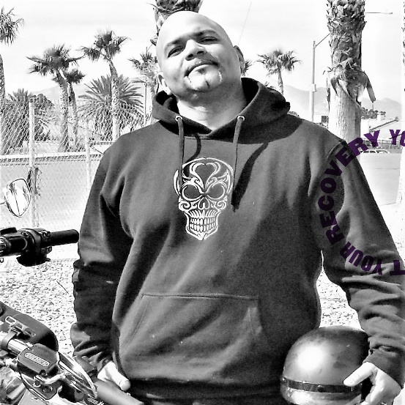

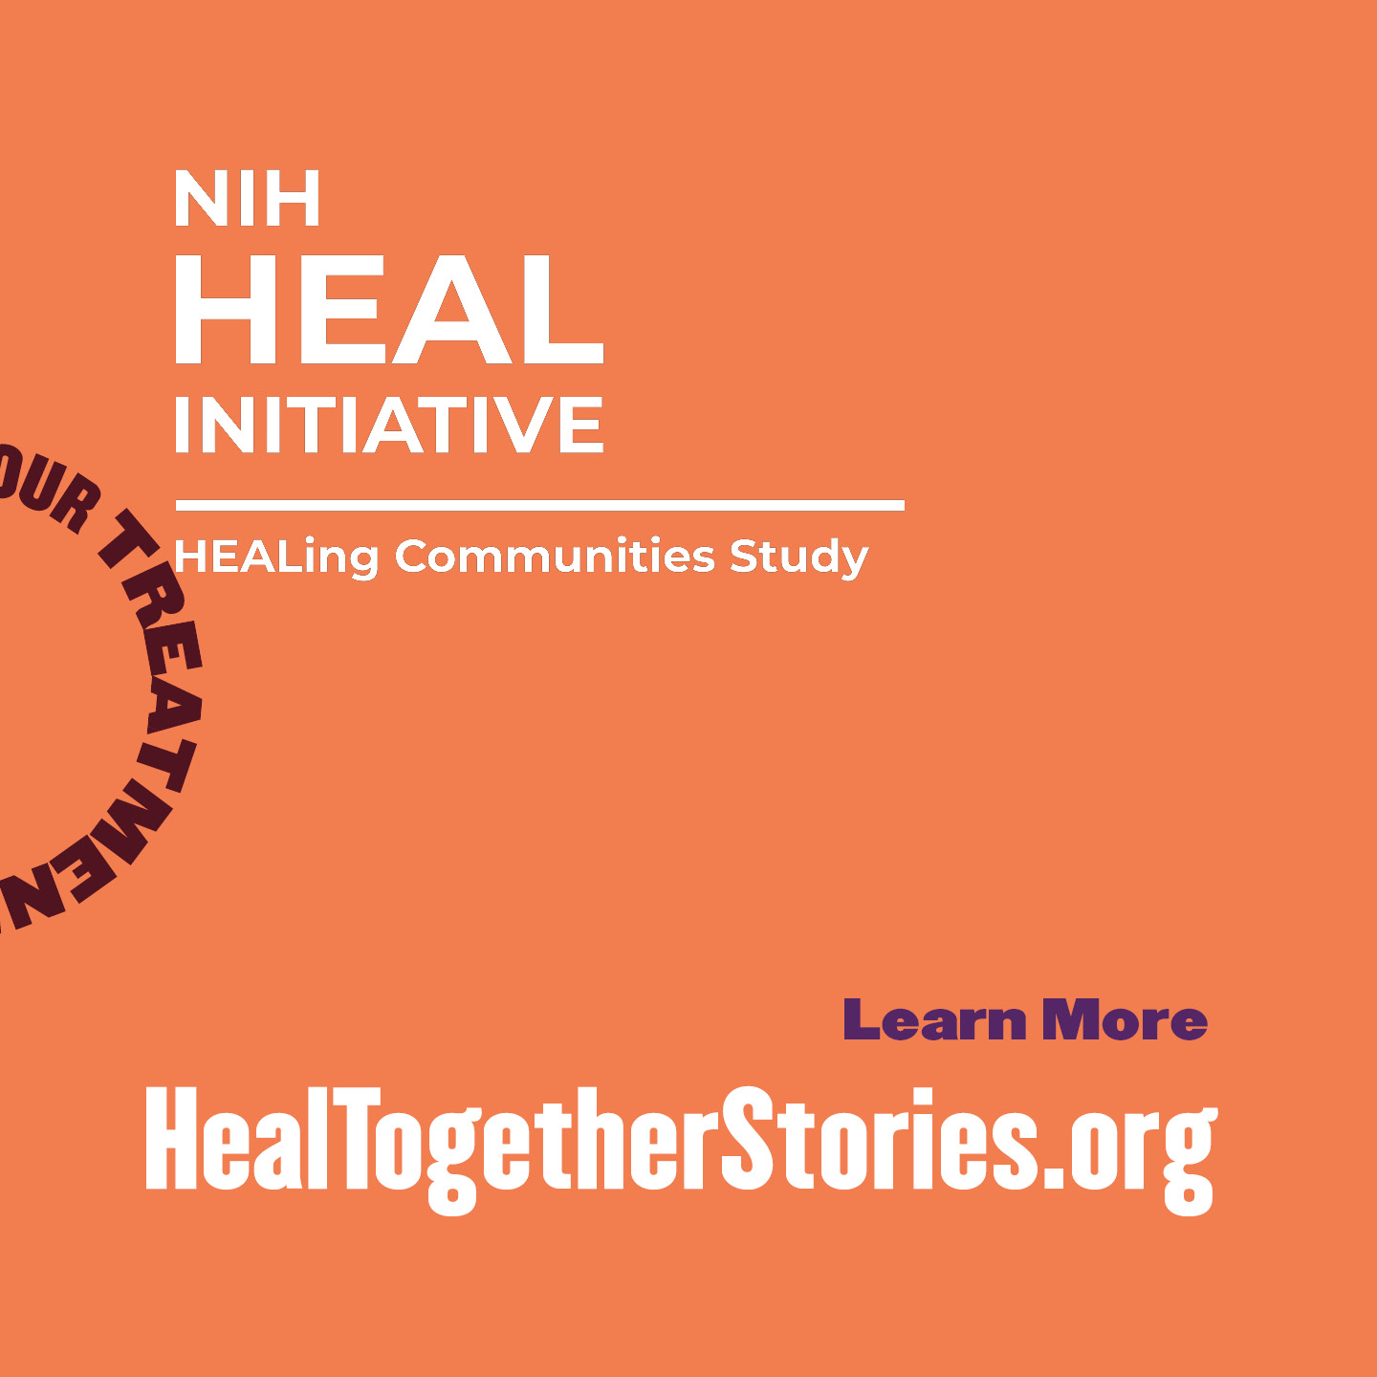

# Brian

## Post Text

As a person in long-term recovery from opioid use disorder and a peer support specialist, Brian knows that many people in recovery struggle with guilt about things they have done in the past. His advice? Focus on your treatment and recovery now and learn to love yourself. Hear more tips for staying in medication treatment at [www.HealTogetherStories.org](http://www.HealTogetherStories.org).

## Images (4)

## 

# Shannon

## Post Text

Stigma keeps people who are struggling with opioid use disorder from getting help and staying in treatment for as long as they need it. Learn what you can do to end stigma in [insert

community name]: [insert HCS Community Page link]

## Images (4)

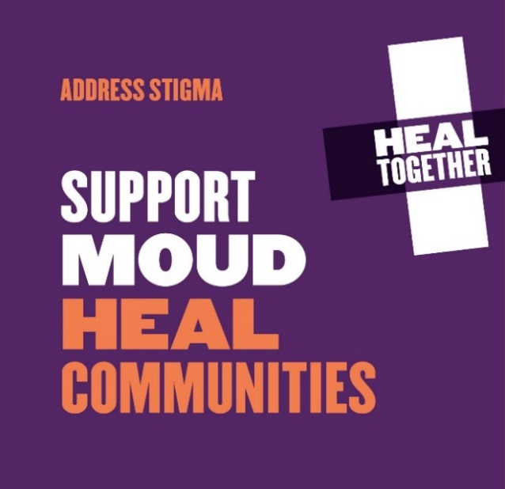 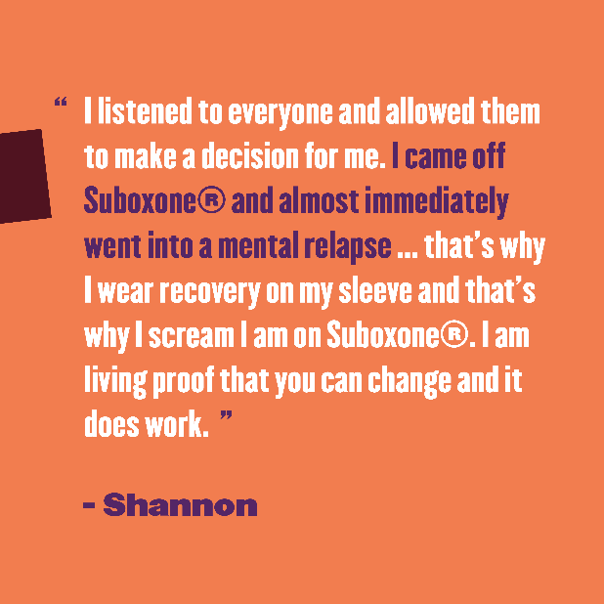 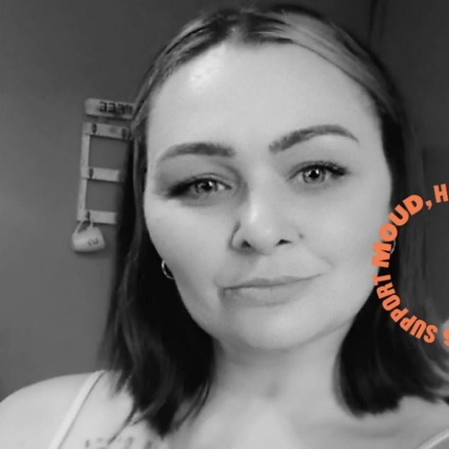 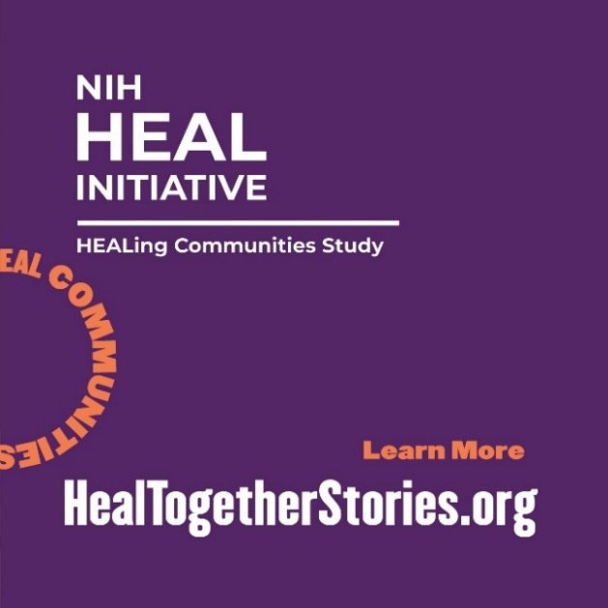

# Additional Posts, Links, and Graphics

## Additional Content to Promote Campaign 4

## Post 1

Medications for opioid use disorder save (or improve) lives. And it is important to stay in medication treatment as long as needed. Treatment takes time, but it also gives time back. Learn more: [www.HealTogetherStories.org](http://www.HealTogetherStories.org).

## Post 2

Recovery is possible with medications for opioid use disorder. Staying in medication treatment as long as you need is the best way to reach your goals and enter long-term remission and recovery. Learn more: [www.HealTogetherStories.org](http://www.HealTogetherStories.org).

## Post 3

## Medications for opioid use disorder save (or improve) lives. Trust yourself and your doctor and stay in treatment as long as you need to achieve your goals. Learn more: [www.HealTogetherStories.org](http://www.HealTogetherStories.org). Post 4

Medications for opioid use disorder are a path to recovery. Stay in MOUD treatment as long as you need to achieve your goals. Learn more: [www.HealTogetherStories.org](http://www.HealTogetherStories.org).

## Links to YouTube Playlists

YouTube Playlist of all **PSAs**: <https://youtube.com/playlist?list=PLq-uBWYn4KRHxb34BeotL0D14hmg13Jo5>

YouTube Playlist of all **Profile Videos**: <https://youtube.com/playlist?list=PLq-uBWYn4KRGp8I_SwFQvS7yFrIoHeVHz>

YouTube Playlist of all **Treatment Challenge Videos:**

* Balancing Treatment with Everyday Life: <https://youtube.com/playlist?list=PLq-uBWYn4KRFjL50Kjc8W80FN_tJNROC1>
* Finding Recovery Support that Accepts MOUD: <https://youtube.com/playlist?list=PLq-uBWYn4KREs0mHFAprjBnwIuEkpbzBh>
* Managing Comments from Others: <https://youtube.com/playlist?list=PLq-uBWYn4KRFg3gUnWgGWXFVIdBR6wiFf>
* Managing Cravings: <https://youtube.com/playlist?list=PLq-uBWYn4KREI3V75FvbC51I15LU2RAgk>
* Managing Triggers (e.g., Friends Who Use Drugs): <https://youtube.com/playlist?list=PLq-uBWYn4KREsM2Ib4oZZVwSgIoZ9N7Sm>
* Managing Sleep Issues: <https://youtube.com/playlist?list=PLq-uBWYn4KRERdsaJnrFsQD_XY2UCt9Kf>
* Managing Anxiety: <https://youtube.com/playlist?list=PLq-uBWYn4KRHSJ47sJZfP37ssZIGJn52f>
* Staying Motivated: <https://youtube.com/playlist?list=PLq-uBWYn4KRHE3xRBtiG6rBcBZ44QQAMO>
* Managing Expectations of Loved Ones: <https://youtube.com/playlist?list=PLq-uBWYn4KRGoF7NrbGn9FnR5CK3elgyV>

## Graphics

