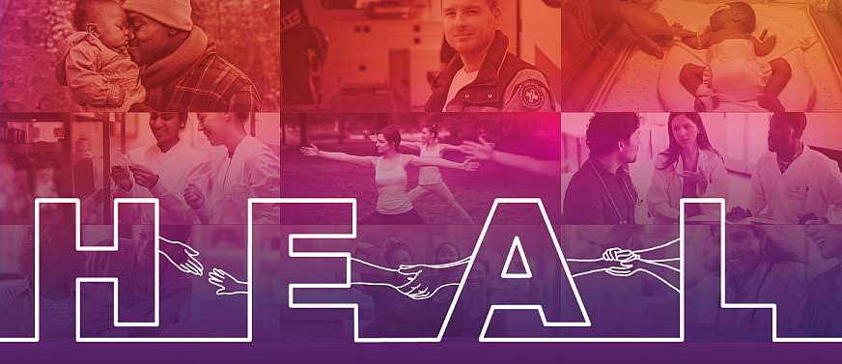

**Communities That HEAL**

## WAVE ONE SAMPLE COPY

### Naloxone • April 2020

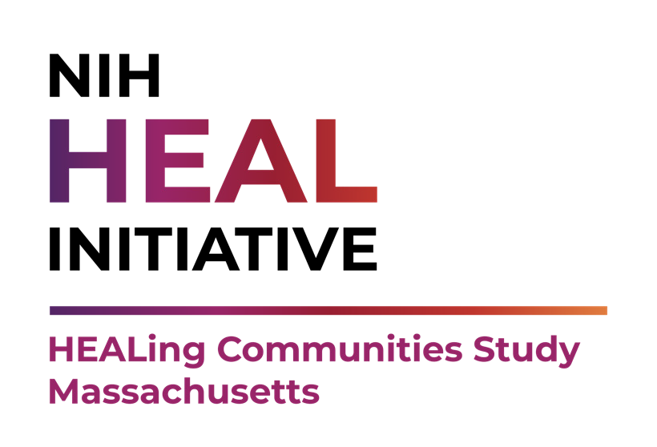

# Sample Social Media Posts

Sample copy for social media posts is provided below.

##### Post 1:

##### 6 Ways to Support People with an Opioid Use Disorder during the COVID-19 Pandemic

##### 1. Get trained and carry Naloxone (Narcan®) to reverse an overdose. Learn how: [insert HCS community specific link – e.g., www. HEALTogetherMA.org/Community].

##### 2. Call them. Offer compassion, encouragement, and support.

##### 3. Encourage them to seek treatment (if they are ready) and to seek prevention services at a local syringe services or harm reduction program. [insert link to local community SSP or harm reduction programs and hours, if applicable]

##### 4. Encourage those already in treatment to stay engaged by calling their provider about tele-health appointments and take-home medication.

##### 5. Connect them with organizations offering virtual recovery support. Start here: <https://bit.ly/2vWT1St>

##### 6. Learn how Covid-19 uniquely affects those with opioid use disorder. Start here: <https://bit.ly/3dIkngr>

##### Post 2:

##### We need to look out for each other, now more than ever.

##### People with opioid use disorder may be at increased risk of overdose during social distancing. There is no better time to get trained and keep naloxone (Narcan®) at home. You could save a loved one’s life. Learn how: [insert HCS community specific link – e.g., [www.HEALTogetherMA.org/Community](http://www.HEALTogetherMA.org/Community)].

##### Post 3:

##### Social distancing puts people with opioid use disorder at increased risk for overdose -especially those who were recently released from jail, residential treatment, or a hospital. If you know someone who may be at increased risk, encourage them to get naloxone (Narcan®), learn how to use it, and to tell others where they keep it in case they overdose. Start here: [insert HCS community specific link – e.g., www.HEALTogetherMA.org/Community].

##### Post 4:

##### If you have a loved one who struggles with opioid use disorder, have naloxone (Narcan®) nearby. Encourage your loved one to be trained, carry naloxone (Narcan®), and tell their friends where they keep it in case they overdose. Learn more: [insert HCS community specific link – e.g., www.HEALTogetherMA.org/ Community].

##### Post 5:

##### If you use opioids (like heroin, fentanyl, or prescription painkillers in ways other than prescribed) and were recently released from jail, residential treatment, or a hospital, you may be at risk for an opioid overdose. Get naloxone (Narcan®) and learn how to use it. Be sure to tell your friends where you keep your Narcan® and teach them to use it in case of an overdose. Learn more: [insert HCS community specific link – e.g., www. HEALTogetherMA.org/Community].

##### Post 6:

##### Save a life. Recognize the signs of an opioid overdose. Learn where to get naloxone (Narcan®) and how to use it. Learn more: [insert HCS community specific link – e.g., www. HEALTogetherMA.org/Community].

##### Post 7:

##### If you use opioids (like heroin, fentanyl, or prescription painkillers in ways other than prescribed), talk to your doctor or pharmacist about Naloxone (Narcan®). It can save your life. Learn more: [insert HCS community specific link – e.g., www.HEALTogetherMA.org/Community].

##### Post 8:

##### Let’s not allow the Covid-19 pandemic to impact the progress our community has made to address the opioid crisis. People who struggle with opioid use need our support now more than ever. [Insert community specific resources or actions]. Learn more: [insert HCS community specific link – e.g., www.HEALTogetherMA.org/Community]

##### Post 9:

##### Emergency medical services may be stretched during the COVID-19

##### pandemic and slower to respond to 911 calls. Protect yourself and others from #opioidoverdose with the following tips:

##### Get naloxone (Narcan®) and learn how to use it. Start here: [insert HCS community specific link – e.g., www. HEALTogetherMA.org/Community].

##### If you are taking drugs alone, start slow. Use less than your normal amount to test the strength.

##### If you are with friends, make an overdose plan. Tell them where you keep your Narcan® and make sure they know how to use it. Take turns in case one of you needs Narcan®.

##### Read more harm reduction tips: <https://harmreduction.org/wp-content/uploads/2020/03/COVID19-safer-drug-use-1.pdf>

##### Post 10:

##### Click on the following links to find resources about coronavirus

##### (COVID-19) to help individuals, people with substance use disorders and in recovery, providers, the justice system, communities, and states across the country:

##### National Institute of Drug Abuse [link to https://www.drugabuse.gov/related- topics/covid-19-resources]

##### National Institutes of Health [link to https://www.nih.gov/health-information/ coronavirus]

##### Substance Abuse and Mental Health Services Administration [link to https:// www.samhsa.gov/coronavirus]

# Sample Outreach Support Letter

**PURPOSE:** Send this to partner organizations to secure their support in expanding the campaign’s reach in your community

Dear [INSERT NAME],

As you may know, [INSERT NAME OF COMMUNITY or COALITION] is participating with Boston Medical Center (BMC) in the HEALing Communities Study (HCS). The goal of the study is to reduce opioid-related overdose deaths by 40% over the course of three years.

Today, we are excited to announce the launch of a new communications campaign in support of this effort. The campaign aims to increase demand for and access to medications for opioid use disorder (MOUD) and naloxone (Narcan®). The campaign

also aims to address stigma by educating audiences that opioid use disorder (OUD) is a disease, people with OUD deserve the best medical care possible, and anyone can develop an OUD.

The first phase of the campaign, focused on naloxone, will run from April 22 through May 31, 2020. All 33 HCS communities from across Massachusetts, Kentucky, New York, and Ohio will be participating. [DISCUSS HOW YOUR COMMUNITY IS DISTRIBUTING THE CAMPAIGN AND WHY IT IS RELEVANT DURING COVID-19 (IF APPROPRIATE)].

I am reaching out to request support from our partners. By working together, we can amplify the campaign messages here in [INSERT COUNTY OR CITY].

There are numerous ways [INSERT NAME OF ORGANIZATION] can be involved, including:

* Sharing our campaign content on your social media
* Sending an email to members of your organization and including a link to our campaign website [insert HCS community specific link – e.g., www.HEALTogetherMA. org/Community]
* Publishing a joint press release
* Hosting or co-hosting a (virtual) community education event
* Displaying campaign posters or materials at your organization’s locations [INSERT DESCRIPTION OF HOW YOU WANT THE ORGANIZATION TO RESPOND (e.g.,

Please email me with how you are willing to support and what materials you would like me to send) OR HOW YOU WILL FOLLOW-UP (e.g., I will be following up next week via phone/email to further discuss).]

If you are already working on an opioid campaign, please tell us about it so we can help promote your efforts as well.

Thank you in advance for your collaboration. If you have any questions, you may contact [INSERT NAME] at [INSERT PHONE NUMBER] or email at [INSERT EMAIL].

# Sample Press Release

**PURPOSE:** A summary of the campaign, including quotes from spokespersons, key messages, important facts, and new information about an issue to “sell” the story idea to the media and help journalists write or produce news pieces.

[ADD DATE} [INSERT NAME OF COMMUNITY COALITION/STEERING COMMITTEE] is

excited to join 33 other communities across Massachusetts, New York, Kentucky and Ohio in launching the first communications campaign for the Healing Communities Study.

The campaign aims to increase demand for medications for opioid use disorder (MOUD) and naloxone (also known as Narcan®), increase MOUD prescribing, and increase access to and availability of naloxone. The campaign also aims to address stigma by educating audiences that opioid use disorder (OUD) is a disease, people with OUD deserve the best medical care possible, and anyone can develop an OUD.

The first phase of the campaign is focused on naloxone, a medicine that can save someone’s life if they are overdosing on opioids, whether it is a prescription opioid pain medicine, heroin, or a drug containing fentanyl. Anyone - EMS, firefighters, loved ones of those with OUD, and community members - can be a first responder and give naloxone to someone who is overdosing from opioids.

[INSERT QUOTE FROM YOUR COALITION’S SPOKESPERSON]

##### About the HEALing Communities Study

The National Survey on Drug Use and Health (NSDUH) estimates that 2.1 million Americans have OUD, yet fewer than 20% of those receive specialty care in a given year. A menu of evidence-based practices (EBPs) exists, including opioid overdose education and naloxone distribution programs, prescription drug monitoring programs, FDA-approved medications for opioid use disorder, behavioral therapies, and recovery support services.

Unfortunately, these EBPs have largely failed to penetrate community settings. As a result, the National Institutes of Health (NIH) and the Substance Abuse and Mental Health Services Administration (SAMHSA) launched the HEALing Communities Study (HCS) to identify the EBPs that are most effective at the local level in preventing and treating OUD. The goal of the study is to reduce opioid-related overdose deaths by 40 percent over the course of three years. To reach this goal, a core component of the HCS intervention is

a series of community-based health communication campaigns. To learn more about the study and how to get involved, please visit:

* Website: [insert community vanity url (e.[g., www.HEALTogetherMA.org/Community)]](http://www.HEALTogetherMA.org/Community))
* Facebook: [insert coalition Facebook you will be sharing information on if applicable]
* Twitter: [insert coalition Twitter account you will be sharing information on, if applicable]

# Sample Newsletter Article

**PURPOSE:** Ask partner organizations to include this in their newsletters to increase reach of the campaign materials, key messages, and calls to action.

##### [INSERT NAME OF COMMUNITY COALITION] Joins Campaign to Help Reduce Opioid-Related Overdose Deaths

Many people living in [INSERT NAME OF COMMUNITY] are worried about a relative, friend, or neighbor who struggles with opioid use. Often, people want to help others get the help they need, but they do not know what to do.

They are not alone. The National Survey on Drug Use and Health (NSDUH) estimates that

2.1 million Americans have opioid use disorder, yet fewer than 20% of those people receive the specialty care they need in a given year. The good news is that there are many proven treatments that can help people with an opioid use disorder (OUD).

These are called evidence-based practices, and they include opioid overdose education and naloxone (Narcan®) distribution programs; prescription drug monitoring programs; and FDA-approved medications for opioid use disorder (such as buprenorphine, more commonly known as Suboxone or Subutex) often used in combination with behavioral therapies and recovery support services.

Unfortunately, these evidence-based practices may be unavailable, underused, or difficult to access in many communities. This is the reason [INSERT NAME OF COMMUNITY COALITION] is participating in the HEALing Communities Study campaign, led by Boston Medical Center (BMC).

The campaign aims to increase prescribing and use of medications for opioid use disorder and increase access to and availability of naloxone to save lives in our communities. To do so, the campaign will be reaching out to pharmacists and doctors about prescriptions, community leaders about policies, and the public about the importance of medications in successful treatment of opioid use disorder and preventing overdose deaths.

The goal is an ambitious and important one: to reduce overdose deaths resulting from opioid use disorder by 40% in [INSERT NAME OF COMMUNITY].

[INSERT QUOTE FROM YOUR COALITION’S SPOKESPERSON]

For more information about the campaign and local resources available, visit [insert community vanity url (e.[g., www.HEALTogetherMA.org/Community)]](http://www.HEALTogetherMA.org/Community)) or contact [INSERT NAME] at [EMAIL/PHONE NUMBER].