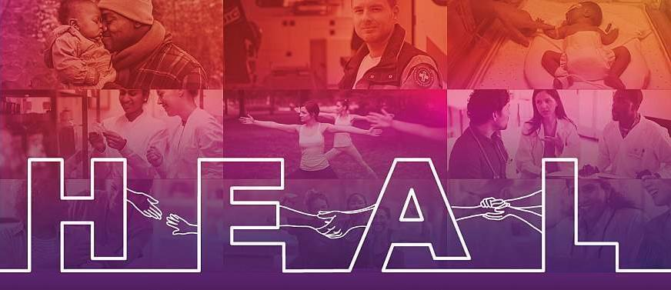

Communities That HEAL

Dissemination Toolkit

Wave One, Campaign One: Naloxone-Fentanyl Education
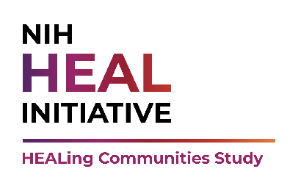
2/23/22

Toolkit Overview

Intended User
The HEALing Communities Study (HCS) developed this toolkit to help Communities That HEAL – Wave One communities implement the refreshed Wave One, Campaign One (W1C1) focused on naloxone and fentanyl education.

Intended Use
Wave one communities may use and tailor content provided in the toolkit as needed to implement tactics outlined in their dissemination plans if they choose to implement this campaign as their Wave One, Campaign Five (W1C5): Community Choice. However, use of content found in this toolkit is not required.

Toolkit Contents
The toolkit includes:
- Sample social media copy
- Accompanying social media graphics
- Sample op-ed
- Sample partner support email

Campaign Overview

Background
Provisional data from CDC’s National Center for Health Statistics over a 12-month period ending in April 2021 indicate overdose deaths from opioids have increased almost six-fold from the year before. Overdose deaths from synthetic opioids – primarily fentanyl – have also increased. Due to this trend, several wave one communities have expressed the need to address fentanyl education in their communities. As a result, the HEALing Communities Study (HCS) has revised W1C1 to include fentanyl education messaging with a “carry naloxone” call to action.

Priority Audience Groups
The W1C1: Naloxone-Fentanyl education campaign aims to reach:
- People who use drugs, which may be contaminated with fentanyl (e.g., counterfeit painkillers and benzodiazepines, heroin, cocaine, and methamphetamine), are ages 18+, live in wave one communities, and do not know about and do not seek fentanyl.
- People who use drugs, which may be contaminated with fentanyl (e.g., counterfeit painkillers and benzodiazepines, heroin, cocaine, and methamphetamine), are ages 18+, live in wave one communities, and know about and/or seek fentanyl.
Single Overarching Communication Objectives (SOCOs)
The SOCO is the change we want to see in the audience(s) as a result of campaign communication and helps guide message development. This campaign aims to help priority audience groups achieve the following knowledge or behavioral SOCOs.
Priority Audience Group | Knowledge SOCOs
People who use drugs who do not know about and do not seek fentanyl | - Understand that many drugs can be contaminated with fentanyl, and that fentanyl is dangerous, even in small doses  - Understand that using a drug potentially contaminated with fentanyl is especially dangerous when no one else is present, able to respond, rescue with naloxone, and call 911 for help.  - Understand that naloxone can reverse overdoses and save lives, and anyone can carry it and use it  - Understand that naloxone trainings are available in their community which provides free naloxone and training on how to use it  - Carry and use naloxone immediately if an overdose is suspected (don’t hesitate)
People who use drugs and know about and/or seek fentanyl | - Understand harm reduction approaches to reduce overdose risk  - Understand that using a drug potentially contaminated with fentanyl is especially dangerous when no one else is present, able to respond, rescue with naloxone, and call 911 for help.  - Understand that naloxone can reverse overdoses and save lives, and anyone can carry it and use it  - Understand that naloxone trainings are available in their community which provides free naloxone and training on how to use it  - Carry and use naloxone immediately if an overdose is suspected (don’t hesitate)
Behavioral SOCO / Call to Action
Help save lives – carry naloxone and learn how to use it: [insert HCS community vanity url]

Campaign Guidelines
Due to study requirements, wave one communities must adhere to the following campaign guidelines when using the NIH HEAL InitiativeSM + HCS wordmark:
- HCS-branded campaign messaging cannot include any reference to fentanyl test strips
  - NOTE: HCS is currently working to build an evidence-base for the use of fentanyl test strips that will support the development of approved messaging. However, at this time, this work is in progress and approved messaging is not available to include in this toolkit.
- HCS-branded campaign messaging can include harm reduction messaging (e.g., “go slow”, “try not to use alone”)
- With more than one medication on the market, HCS-branded campaign messaging must refer to the generic medication, “naloxone”
- HCS-branded campaign materials should not contain imagery of pills, drugs, or syringes as these can be triggering for the target audience
Communities can refer to the NIH HEAL InitiativeSM Official Style Guide for additional guidance on appropriate wordmark use.

Additional Resources
The HEALing Communities Study (HCS) has developed a fentanyl backgrounder that provides additional, HCS-approved messaging on this topic.
PURPOSE: Sample copy for social media posts is provided below. Edit the sample copy as needed to meet the unique needs of your community and desired social media platform.

GRAPHICS: Graphics provided are 1200 x 628 pixels in size, ideal for sharing on social media. To save graphics, right click on the desired graphic and select “Save as Picture”.

CUSTOMIZATION: Your community can submit a request to customize (e.g., resize, change imagery) any graphic in order to implement tactics outlined in your dissemination plan. Contact your research site lead for your site-specific customization process.

Social Media Content

Target Audience: People Who Use Drugs Who Do Not Know About and Do Not Seek Fentanyl
Post 1 in English
Drugs containing #fentanyl, even in very small amounts, substantially increase the risk of overdose and death. Naloxone is an FDA-approved medication that works to reverse an opioid #overdose, including fentanyl overdose. Help save lives – carry #naloxone and learn how to use it: [insert HCS community vanity url] 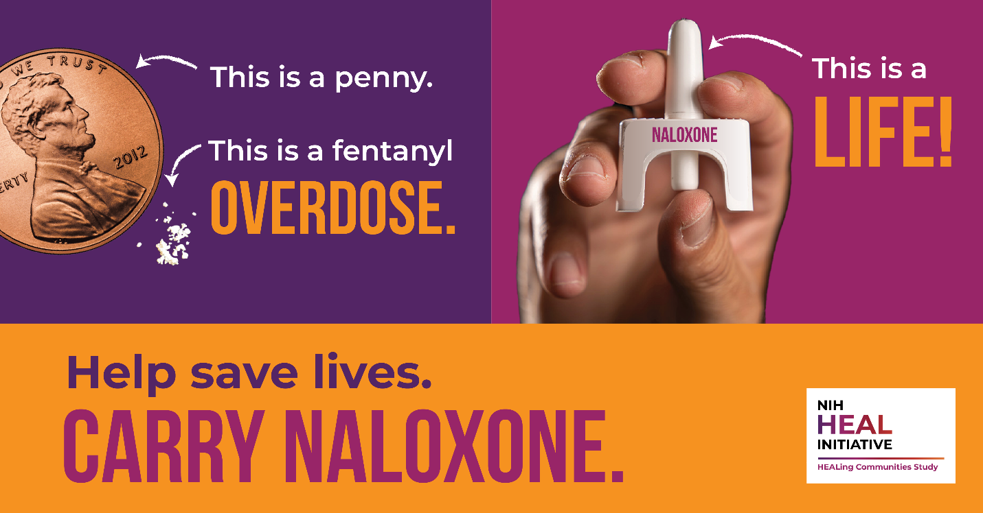
Post 1 in Spanish
Los medicamentos que contienen #fentanilo, incluso en cantidades muy pequeñas, aumentan considerablemente el riesgo de sobredosis y muerte. La naloxona es un medicamento aprobado por la FDA que actúa para revertir una #sobredosis de opioides, incluida la sobredosis de fentanilo. Ayude a salvar vidas: lleve consigo #naloxona y aprenda a usarla: [insert HCS community vanity url]

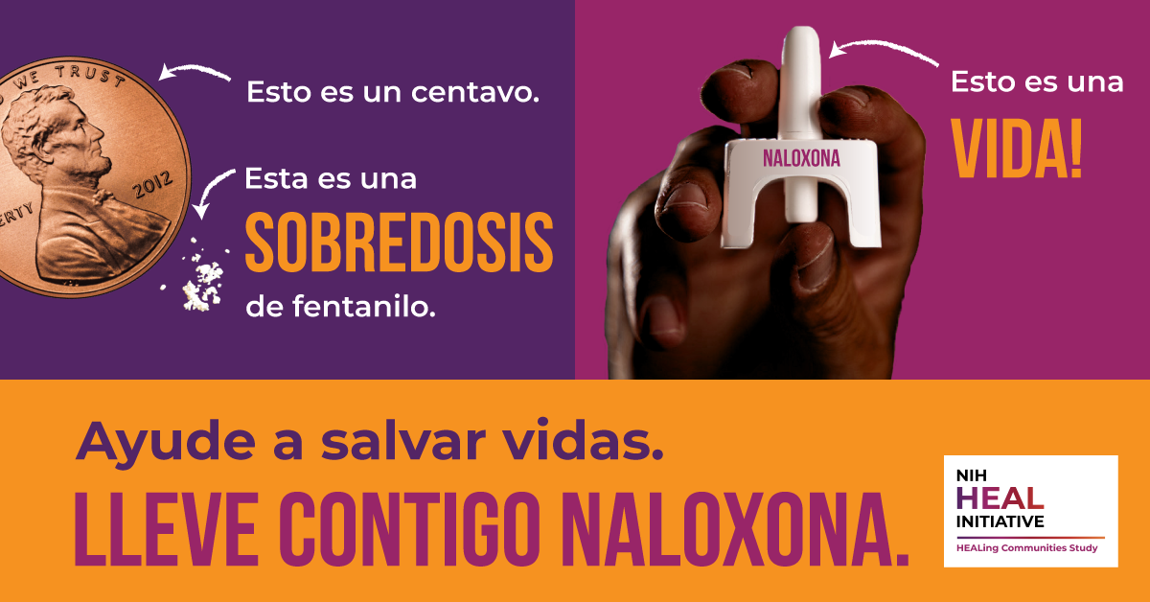

Post 1 in Cape Verdean Creole
Ramedi ki ten #fentanil, mésmu ki na poku kuantidadi, ta omenta di forma signifikativu risku di overdozi y mórti. Naloxona é un ramedi aprovadu pa FDA ki ta funsiona pa riverti un #overdozi di opióidi, inkulíndu overdozi di fentanil. Djuda salva vidas - anda ku #naloxona y prende modi ki bu ta uza-l [insert HCS community vanity url]

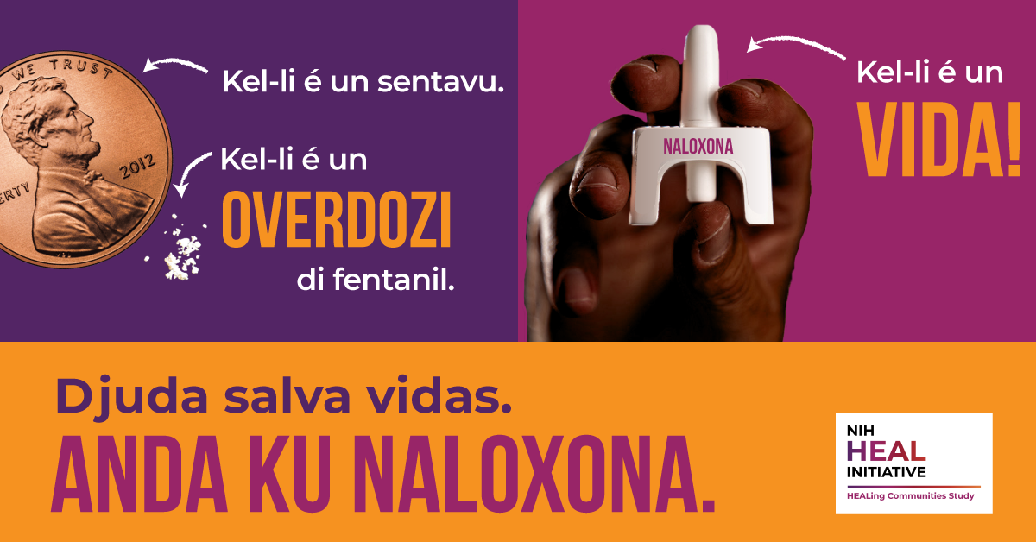

Post 1 in Portuguese
As drogas contêm #fentanil, e mesmo em quantidades muito pequenas aumentam significativamente o risco de superdosagem e morte.A naxolona é um medicamento aprovado pela FDA que funciona como antídoto para a #superdosagem de opioides, inclusive a superdosagem de fentanil. Ajude a salvar vidas – tenha sempre #naloxona com você a aprenda a aplicá-la: [insert HCS community vanity url]

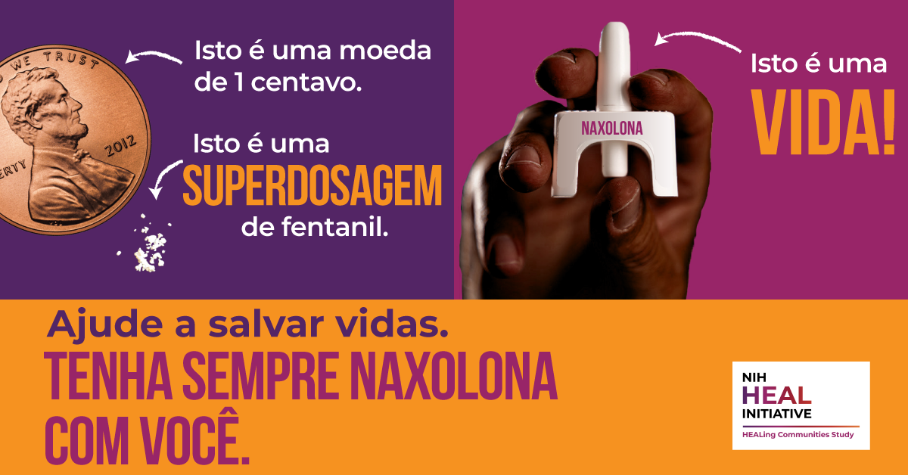

Post 2 in English
#Fentanyl and other synthetic opioids are the leading cause of #overdose deaths in the United States. Anyone can carry and administer naloxone – a life-saving medication that reverses opioid overdoses. Help save lives – carry #naloxone and learn how to use it: [insert HCS community vanity url]

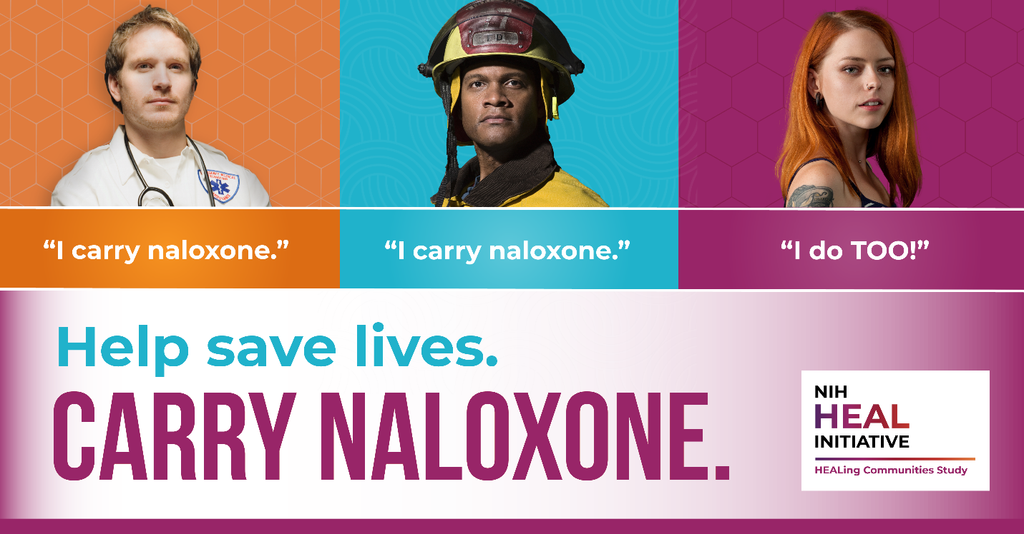

Post 2 in Spanish
El #fentanilo y otros opioides sintéticos son la principal causa de muerte por #sobredosis en Estados Unidos. Cualquiera puede cargar y administrar naloxona, un medicamento que salva vidas y revierte las sobredosis de opioides. Ayude a salvar vidas: lleve consigo #naloxona y aprenda a usarla: [insert HCS community vanity url]

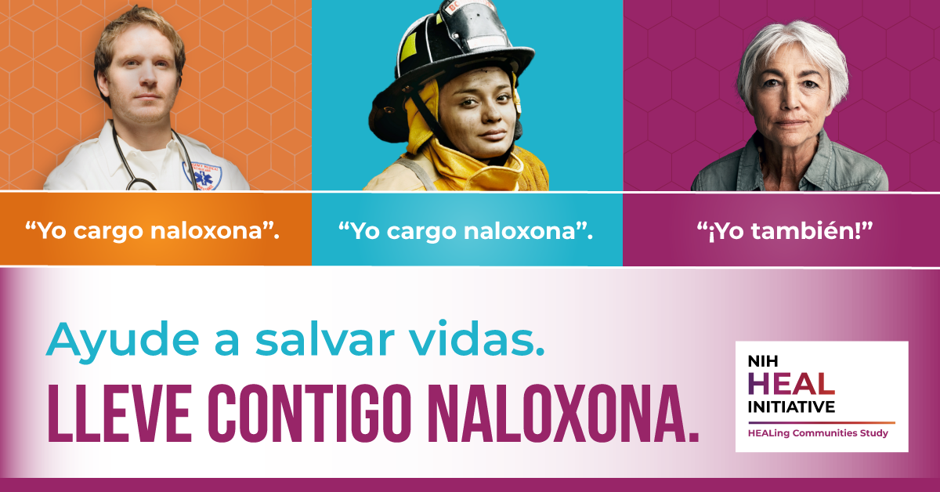
Post 2 in Cape Verdean Creole
#Fentanil y otus opióidis sintétikus é kes prinsipal kauzas di #mórti pa overdozi na Massachusetts. Kualker algén pode anda ku naloxona y administra-l - un ramedi ki ta salva vida ki ta riverti overdozi di opioidis. Djuda salva vidas - anda ku #naloxona y prende modi ki bu ta uza-l [insert HCS community vanity url]

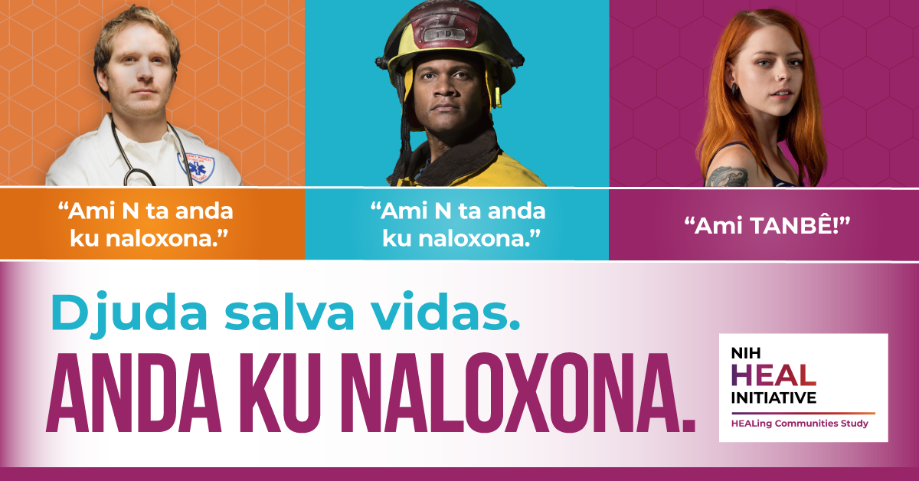

Post 2 in Portuguese
O #fentanil e outros opioides sintéticos são a maior causa de mortes por #superdosagem em Massachusetts. Todo mundo pode ter naxolona sempre à mão e saber como aplicá-la: trata-se de um medicamento que salva vidas e serve de antídoto para superdosagens de opioides. Ajude a salvar vidas – tenha sempre #naloxona com você e aprenda a aplicá-la: [insert HCS community vanity url]

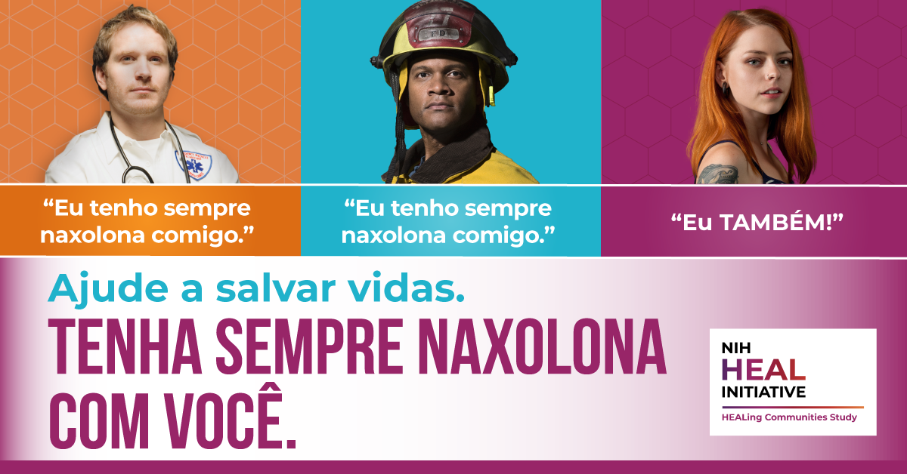

Post 3 in English
#Fentanyl is a powerful synthetic drug that is often mixed with powder and pill forms of drugs and causing overdoses in the United States. Naloxone is an FDA-approved medication that works to reverse an opioid #overdose, including fentanyl overdose.
Help save lives – carry #naloxone and learn how to use it: [insert HCS community vanity url]

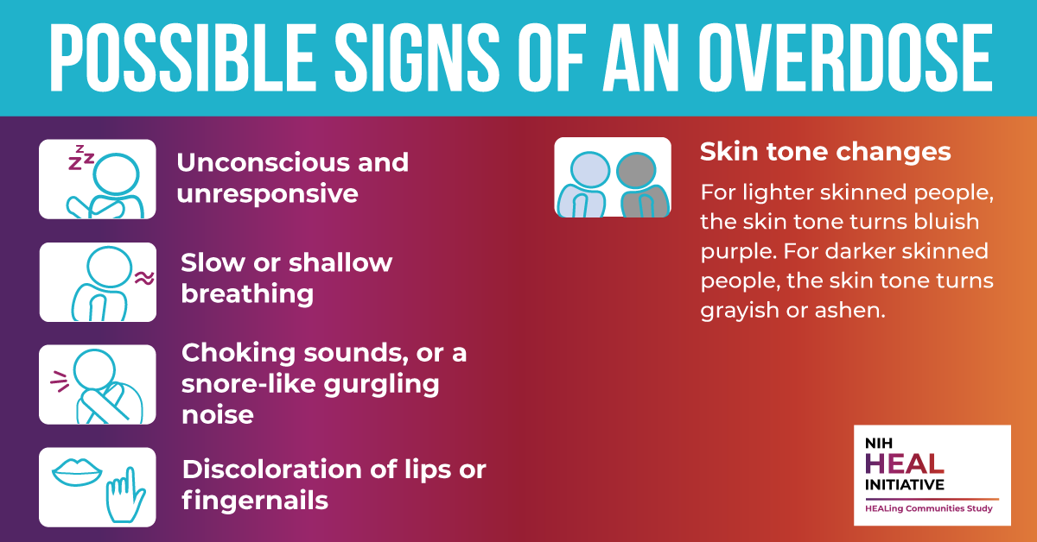

Post 3 in Spanish
El #fentanilo es una potente droga sintética que suele mezclarse con fármacos en polvo y pastillas, y que actualmente está provocando sobredosis en Estados Unidos. La naloxona es un medicamento aprobado por la FDA que actúa para revertir una #sobredosis de opioides, incluida la sobredosis de fentanilo.
Ayude a salvar vidas: lleve consigo #naloxona y aprenda a usarla: [insert HCS community vanity url]

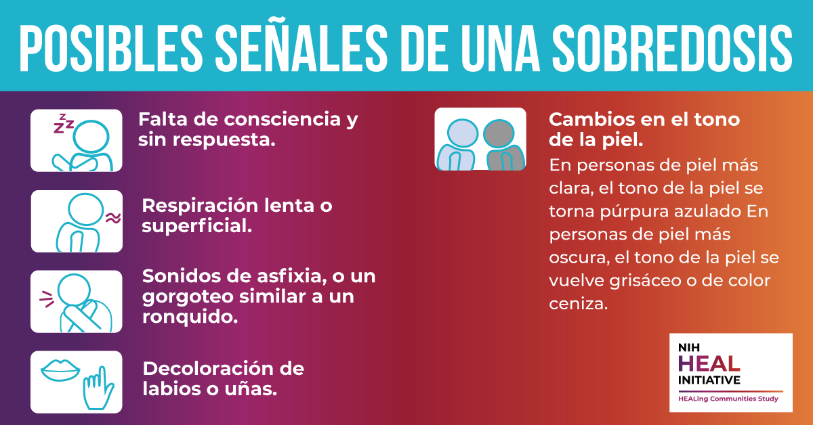
Post 3 in Cape Verdean Creole
#Fentanil é un droga sintétiku forti ki alvés ta misturadu ku pó y ku pílulas y sa ta kauza overdozis na Massachusetts. Naloxona é un ramedi aprovadu pa FDA ki ta funsiona pa riverti un #overdozi di opióidi, inkulíndu overdozi di fentanil.
Djuda salva vidas - anda ku #naloxona y prende modi ki bu ta uza-l [insert HCS community vanity url]

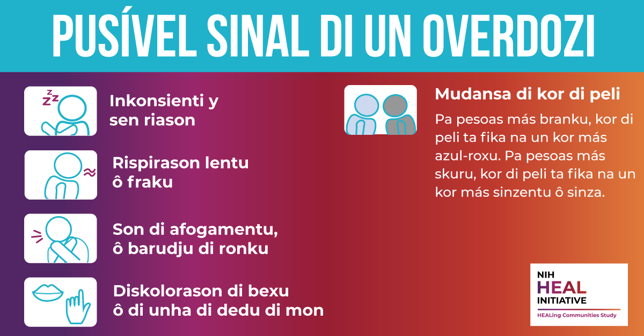

Post 3 in Portuguese
O #fentanil é uma poderosa droga sintética frequentemente misturada com drogas na forma de pó ou comprimidos, e que está provocando casos de superdosagem em Massachussetts. A naxolona é um medicamento aprovado pelo FDA que funciona para reverter a #superdosagem de opioides, inclusive a superdosagem de fentanil.
Ajude a salvar vidas – tenha sempre #naloxona com você e aprenda a aplicá-la: [insert HCS community vanity url]

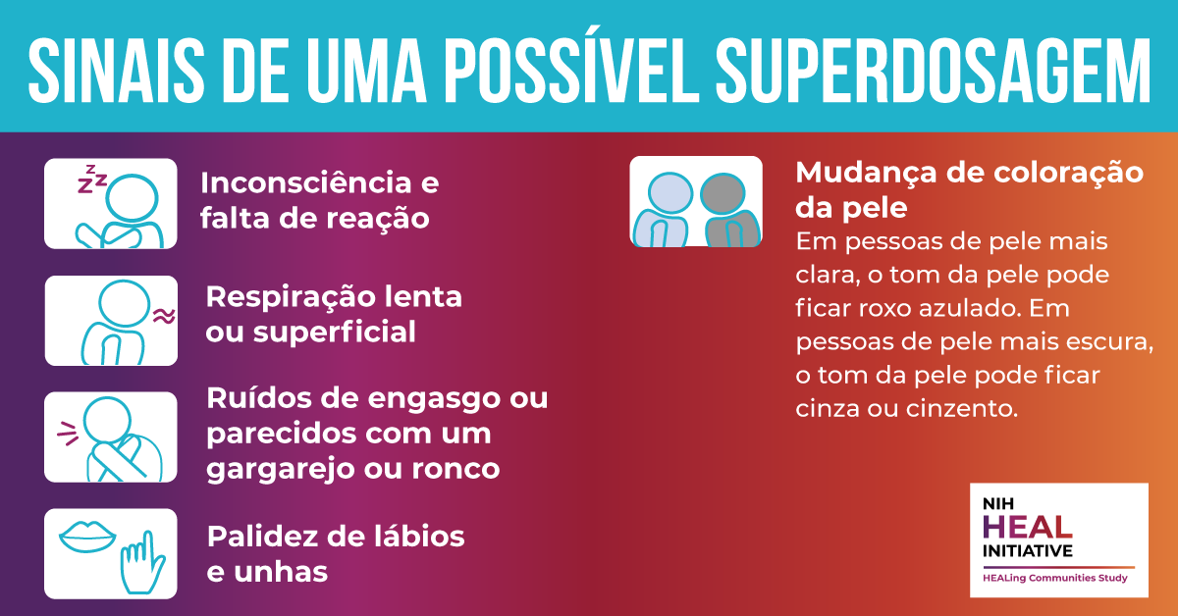

Post 4 in English
Touching someone who has used or overdosed from #fentanyl will not harm you. This incorrect belief hinders rescue of people experiencing an overdose and worsens the stigma faced by #PeopleWhoUseDrugs. It is safe to give someone naloxone and to give rescue breaths.
Help save lives – carry #naloxone and learn how to use it: [insert HCS community vanity url]

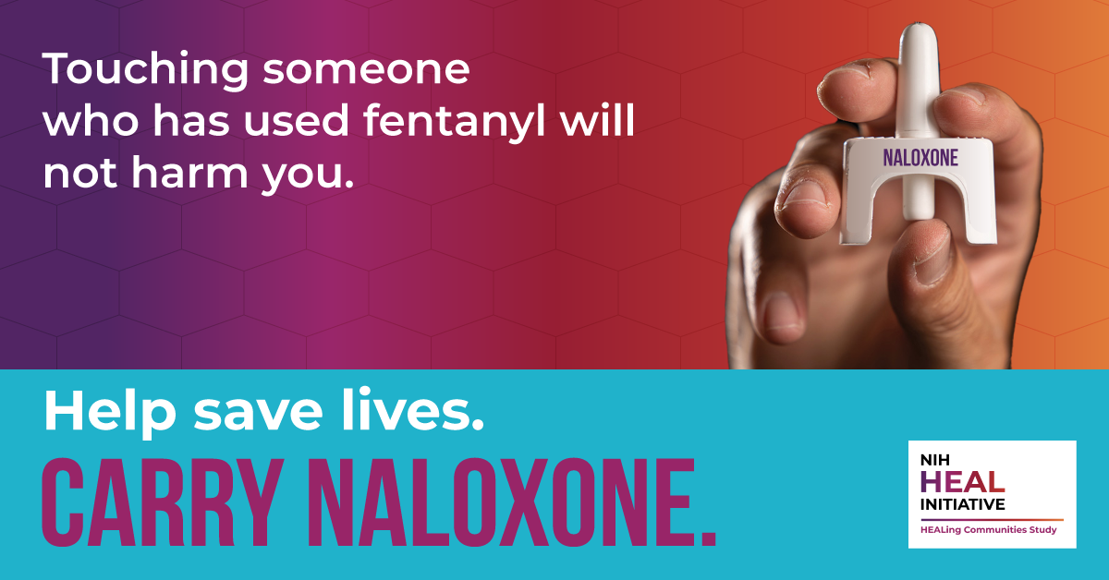

Post 4 in Spanish
Tocar a alguien que haya consumido o tenido una sobredosis de #fentanilo no le hará daño. Esta creencia incorrecta dificulta el rescate de las personas que sufren una sobredosis y agrava el estigma que sufren las #PersonasQueUsanDrogas. Es seguro dar a alguien naloxona y respiración boca a boca.
Ayude a salvar vidas: lleve consigo #naloxona y aprenda a usarla: [insert HCS community vanity url]

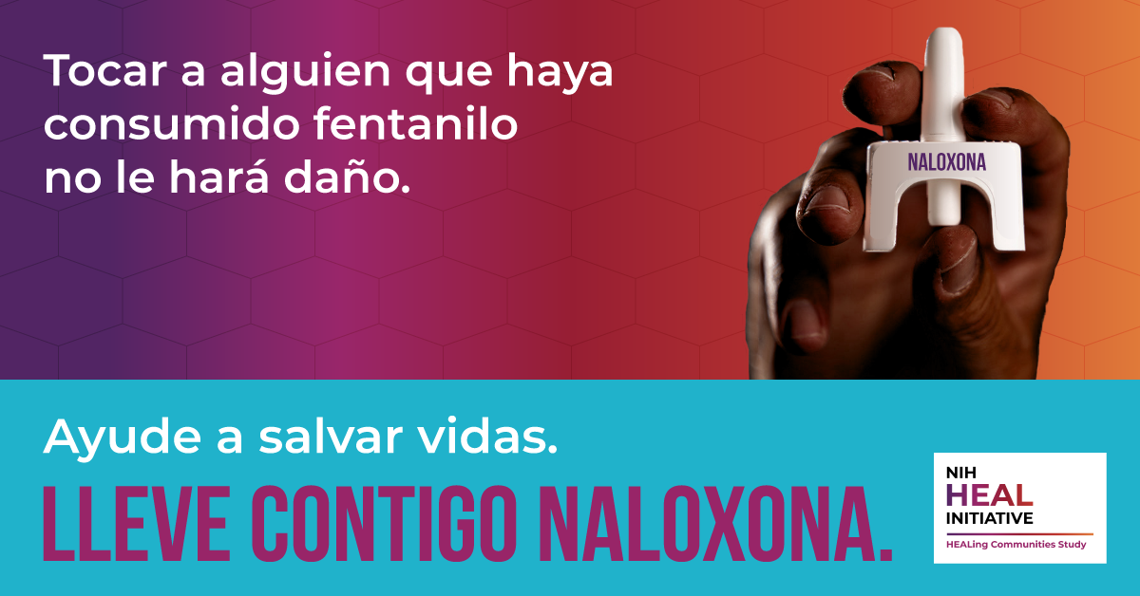

Post 4 in Cape Verdean Creole
Toka na un algén ki dja uza ô dja panha overdozi di #fentanil ka ta faze-bu ninhun mal. Kel krensa inkuretu li ta inpidi risgati di pesoas ki sa ta sufri un overdozi y ta piora kel prubléma infrentadu pa #PesoasKiTaUzaDroga. É siguru da algén naloxona y faze rispirason boka boka.
Djuda salva vidas - anda ku #naloxona y prende modi ki bu ta uza-l [insert HCS community vanity url]

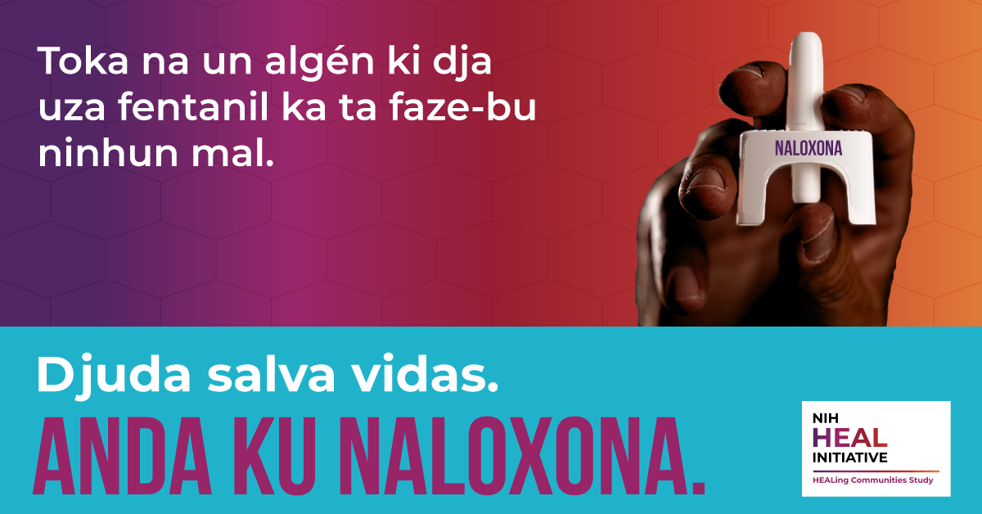

Post 4 in Portuguese
Encostar em alguém que usou ou está em superdosagem de #fentanil não irá prejudicar você. Esta crença equivocada impede o resgate de pessoas que estão tendo uma superdosagem e piora ainda mais o estigma de #UsuáriosDeDrogas.
Administrar naxolona a alguém e fazer respiração boca a boca são medidas seguras.

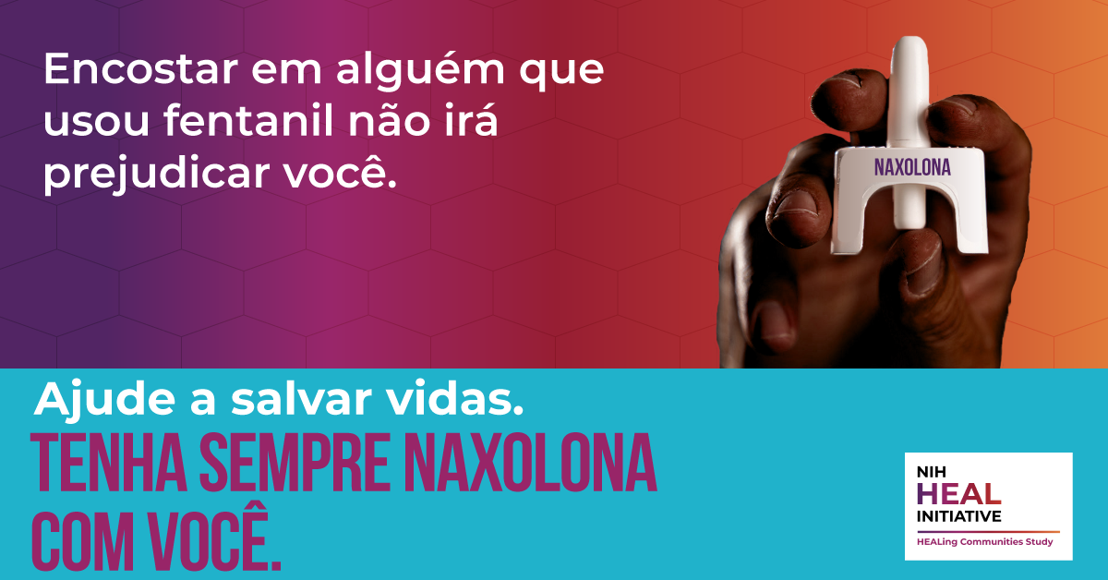

Post 5 in English
Fentanyl is a synthetic opioid that is so strong that a tiny amount, equivalent to several grains of salt, can cause a fatal #overdose in a matter of minutes if naloxone isn’t available. It is difficult for people who use drugs to detect #fentanyl contamination in illicit drugs, placing people at higher risk for overdose and even death.
There is no better time to carry naloxone and learn how to use it. You could help save someone’s life! Learn more: [insert HCS community vanity url]

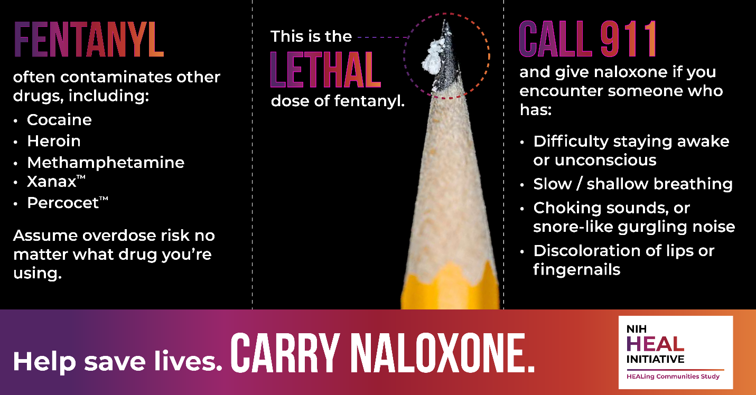

Post 5 in Spanish
El fentanilo es un opioide sintético tan potente que una muy pequeña cantidad, equivalente a varios granos de sal, puede provocar una #sobredosis mortal en cuestión de minutos si no se dispone de naloxona. A las personas que usan drogas les resulta difícil detectar la contaminación por #fentanilo en las drogas ilícitas, lo que supone un mayor riesgo de sobredosis e incluso de muerte.
No hay mejor momento para llevar consigo naloxona y aprender a usarla. ¡Podría ayudar a salvarle la vida a alguien! Aprenda más: [insert HCS community vanity url]
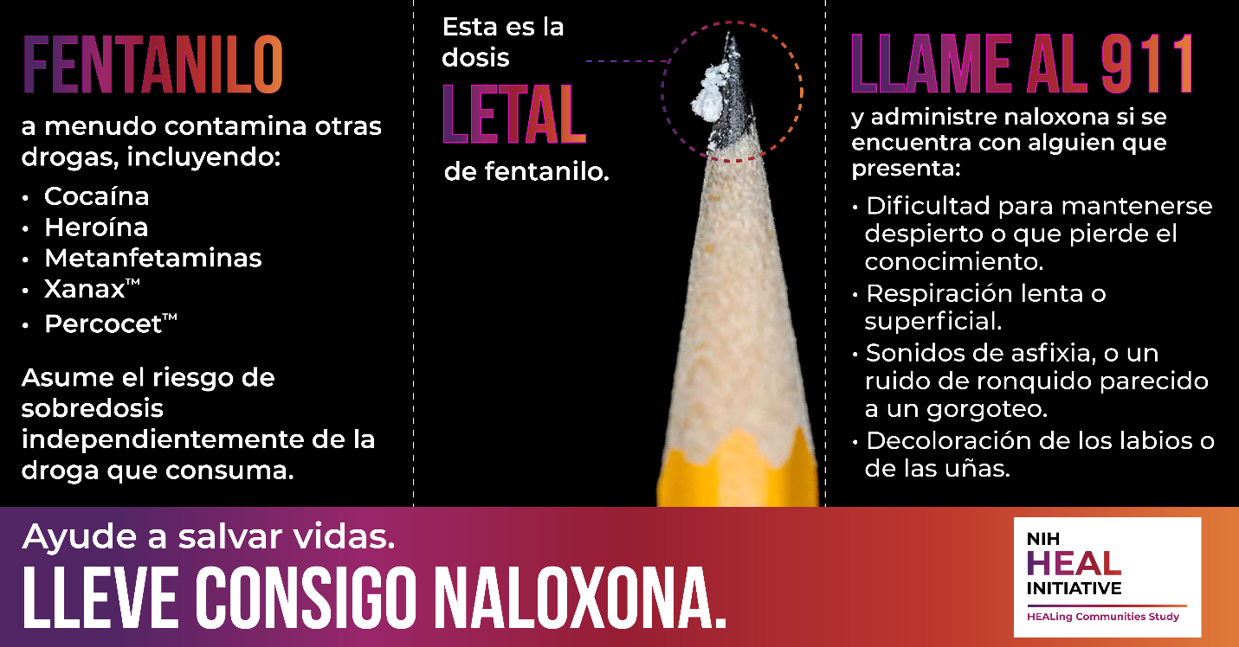
Post 6 in English
Fentanyl is a synthetic opioid that is up to 50 times stronger than heroin, causing an increase in overdoses in the United States. Drugs that are manufactured illegally like counterfeit painkillers and benzodiazepines, heroin, cocaine, and methamphetamine are often contaminated with fentanyl leading to overdoses.

Help save lives – carry #naloxone and learn how to use it: [insert HCS community vanity url]
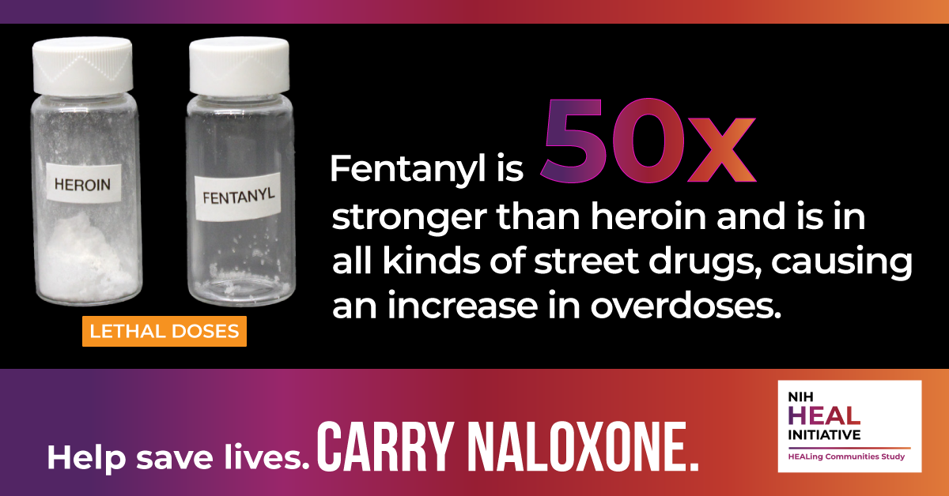

Post 6 in Spanish
El fentanilo es un opioide sintético hasta 50 veces más potente que la heroína, lo que ha provocado un aumento de las sobredosis en Estados Unidos. Los medicamentos fabricados ilegalmente, como los analgésicos y benzodiacepinas falsificados, la heroína, la cocaína y las metanfetaminas, suelen estar contaminados con fentanilo, lo que provoca sobredosis.
Ayude a salvar vidas: lleve consigo #naloxona y aprenda a usarla: [insert HCS community vanity url]
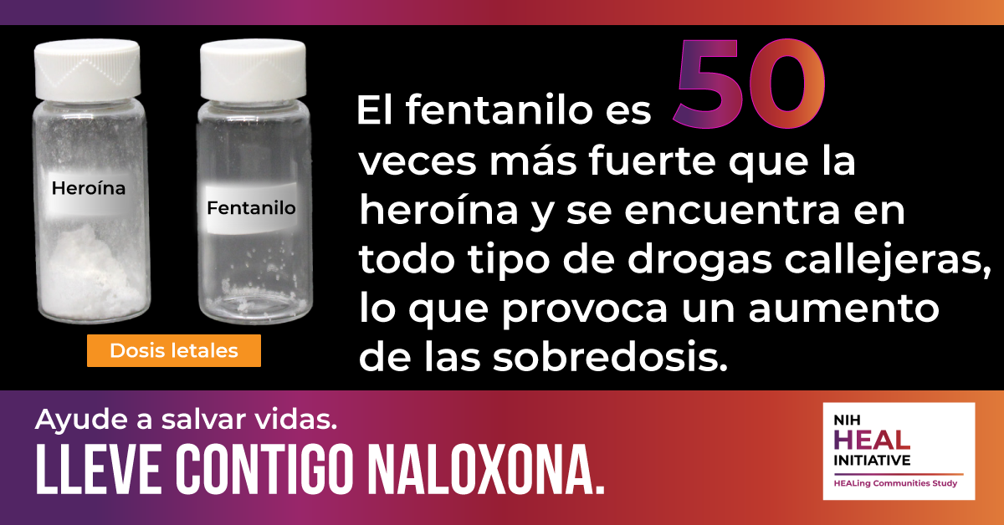

Post 6 in Cape Verdean Creole
Fentanil é un opioidi sintétiku ki é 50 bês más forti ki eroína, u ki ta kauza un omentu di overdozi na Merka. Ramedi fabrikadus ilegalmenti sima analjéziku, benzodiazepínikus falsifikadu, eroína, kokaína, y metafetamina ta sta txeu bês kontaminadu ku fentanil u ki ta leba pa overdozi.

Djuda salva vidas - anda ku #naloxona y prende modi ki bu ta uza-l [insert HCS community vanity url]

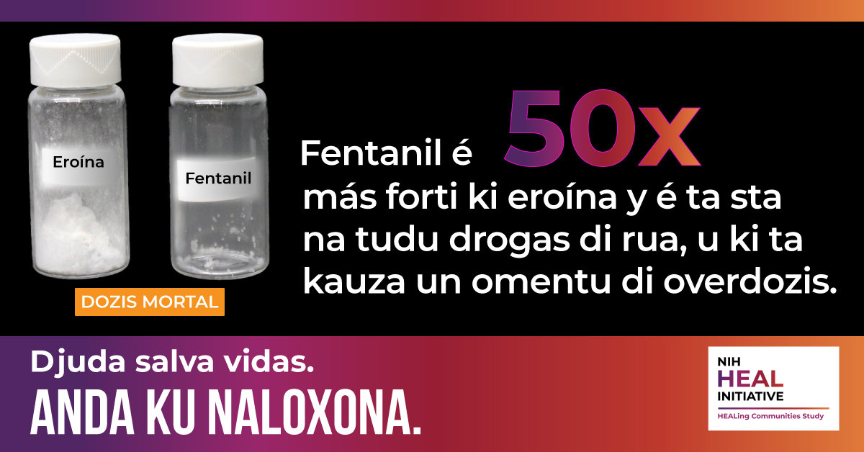

Post 6 in Portuguese
O fentanil é um opioide sintético até 50x mais potente que a heroína e que está provocando um aumento de casos de superdosagem nos Estados Unidos. Drogas fabricadas ilegalmente, como analgésicos e benzodiazepínicos falsificados, heroína, cocaína e metanfetamina são muitas vezes contaminadas com fentanil, e provocam superdosagens.

Ajude a salvar vidas – tenha sempre #naloxona com você e aprenda a aplicá-la: [insert HCS community vanity url]
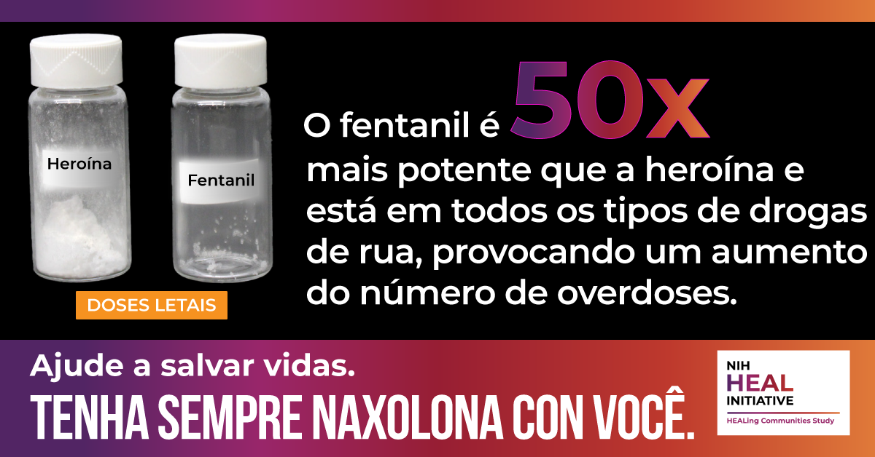

Post 7 in English
Did you know that opioid overdoses are on the rise due to illicit #fentanyl being mixed with other drugs, like counterfeit painkillers and benzodiazepines, heroin, cocaine, and methamphetamine? Naloxone is an FDA-approved medication that works to reverse an opioid overdose, including fentanyl overdose.

Help save lives – carry #naloxone and learn how to use it: [insert HCS community vanity url]
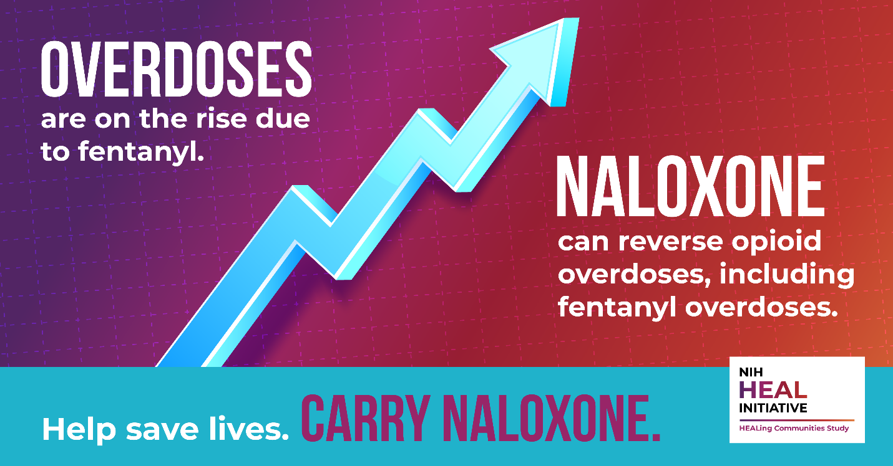

Post 7 in Spanish
¿Sabía que las sobredosis de opioides están aumentando debido a que el #fentanilo ilícito se mezcla con otras drogas, como analgésicos y benzodiacepinas falsificados, heroína, cocaína y metanfetaminas? La naloxona es un medicamento aprobado por la FDA que actúa para revertir una #sobredosis de opioides, incluida la sobredosis de fentanilo.
Ayude a salvar vidas: lleve consigo #naloxona y aprenda a usarla: [insert HCS community vanity url]
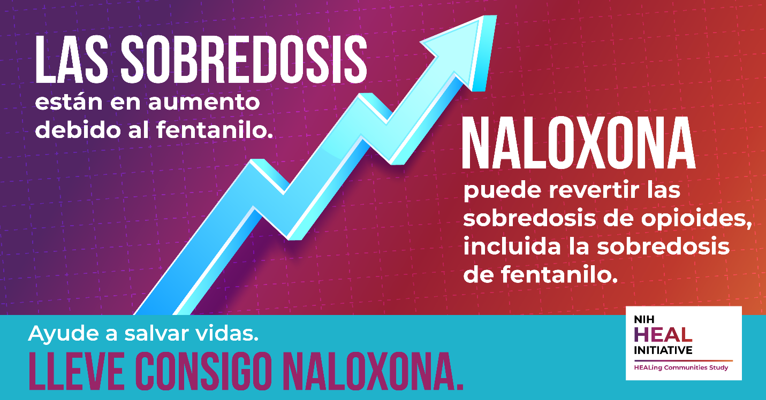
Post 8 in English
#Fentanyl is being mixed with other drugs, like counterfeit painkillers and benzodiazepines, heroin, cocaine, and methamphetamine. This is causing an increase in overdose deaths. Naloxone is an FDA-approved medication that works to reverse an opioid overdose, including fentanyl overdose.
Help save lives – carry #naloxone and learn how to use it: [insert HCS community vanity url]
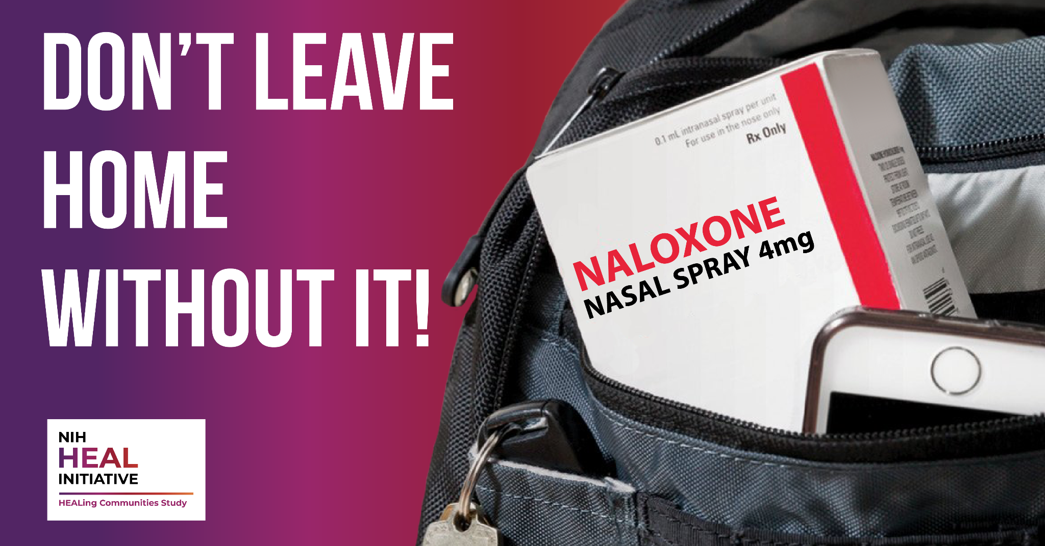

Post 8 in Spanish
El #Fentanilo se está mezclando con otras drogas, como analgésicos y benzodiacepinas falsificados, heroína, cocaína y metanfetaminas. Esto está provocando un aumento de las muertes por sobredosis. La naloxona es un medicamento aprobado por la FDA que actúa para revertir una #sobredosis de opioides, incluida la sobredosis de fentanilo.
Ayude a salvar vidas: lleve consigo #naloxona y aprenda a usarla: [insert HCS community vanity url]
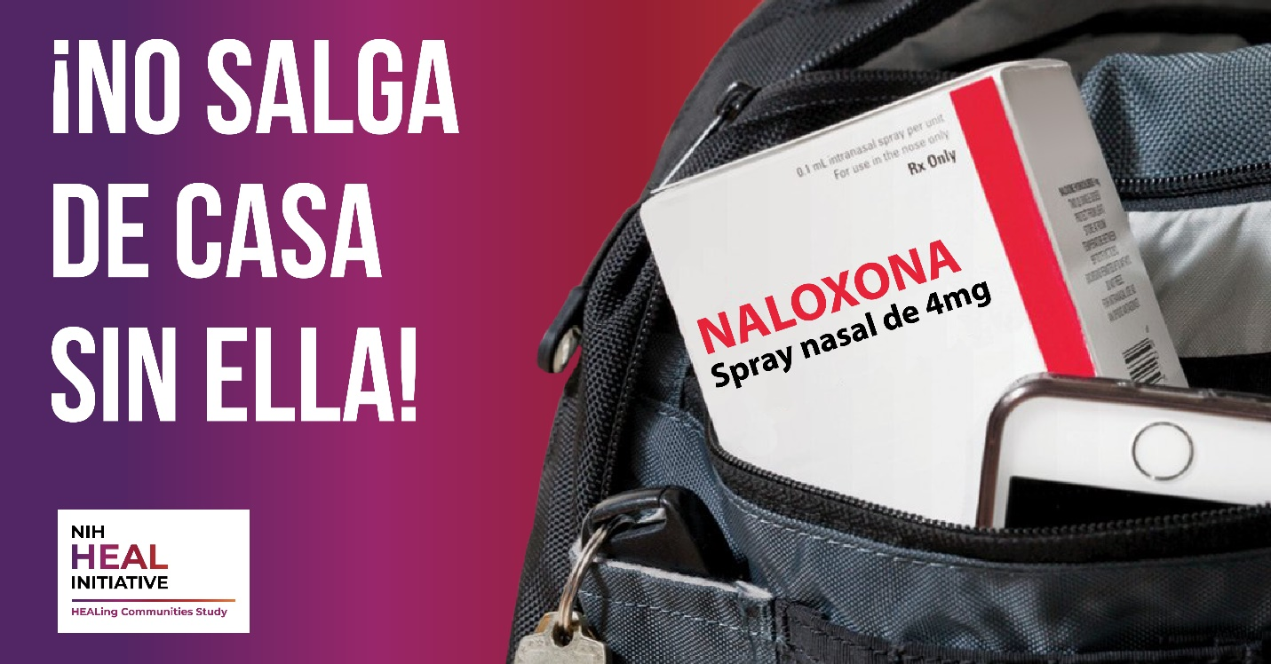
Post 9 in English
In 2020, #fentanyl was present in over 60% of all drug deaths in the U.S. Drugs may contain deadly levels of fentanyl, and you wouldn’t be able to see it, taste it, or smell it. Naloxone, given as a nasal spray, can reverse #overdose and save a life.
Help save lives – carry #naloxone and learn how to use it: [insert HCS community vanity url]
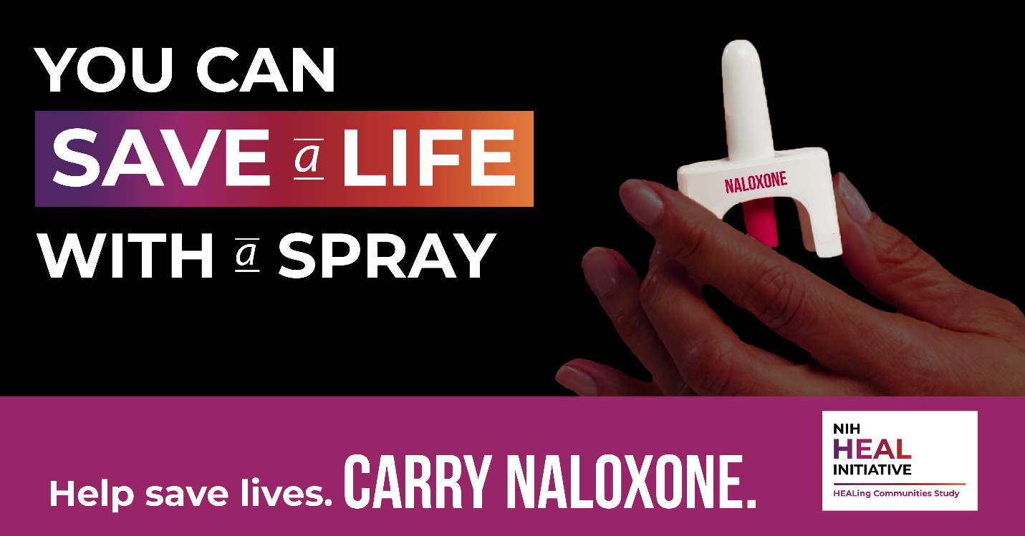

Post 9 in Spanish
En 2020, el #fentanilo estuvo presente en más del 60% de las muertes por drogas en Estados Unidos. Las drogas pueden contener niveles mortales de fentanilo y usted no tiene forma de verlo, saborearlo u olerlo. La naloxona, administrada en forma de spray nasal, puede revertir una #sobredosis y salvar una vida.
Ayude a salvar vidas: lleve consigo #naloxona y aprenda a usarla: [insert HCS community vanity url]
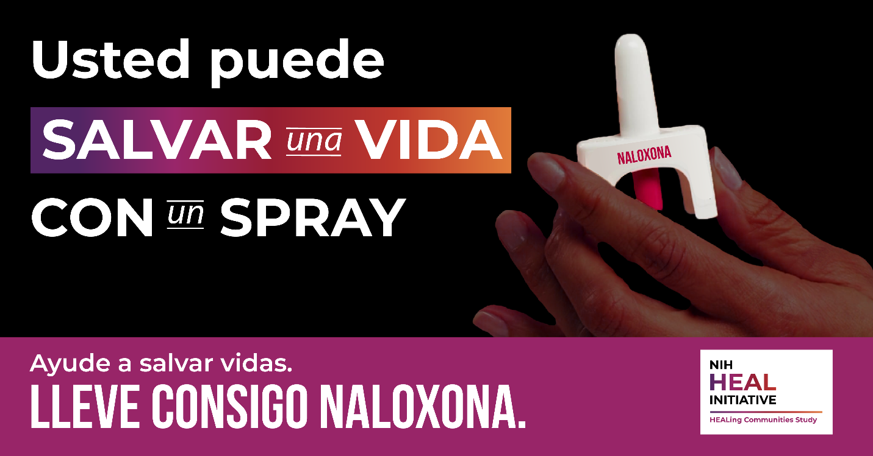
Post 10 in English
In just a few minutes, you can learn how to recognize the signs of an #overdose, give naloxone, and save a life! Mark your calendar, our next #naloxone training will be held on [insert date/time]. Help save lives – carry #naloxone and learn how to use it: [insert HCS community vanity url]
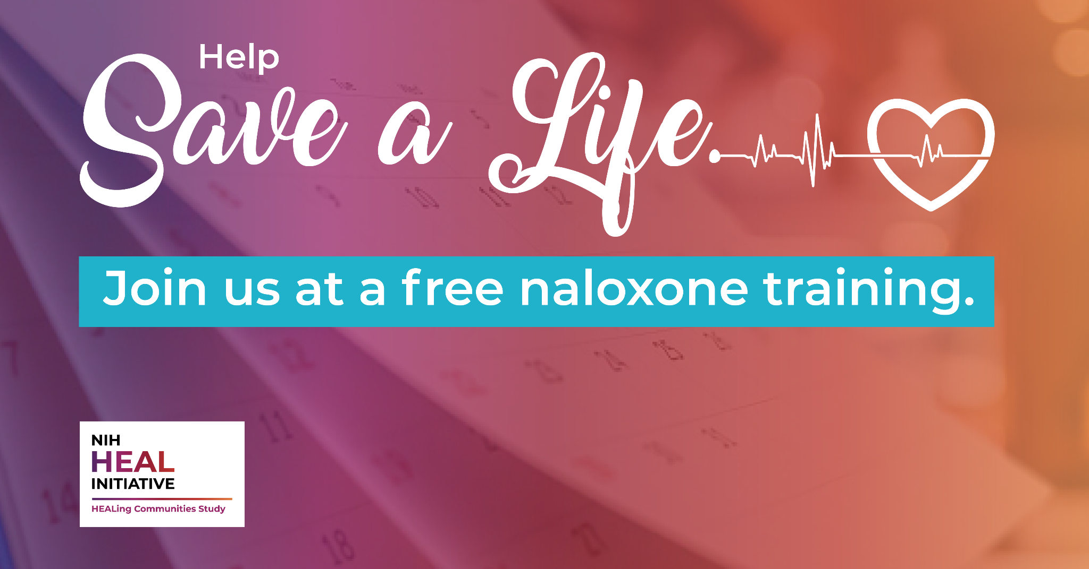

Post 10 in Spanish
¡En sólo unos minutos, puede aprender a reconocer las señales de una #sobredosis, administrar naloxona y salvar una vida! Marque su calendario, nuestro próximo curso de formación de #naloxona se llevará a cabo el [insertar fecha/hora]. Ayude a salvar vidas: lleve consigo #naloxona y aprenda a usarla: [insert HCS community vanity url]
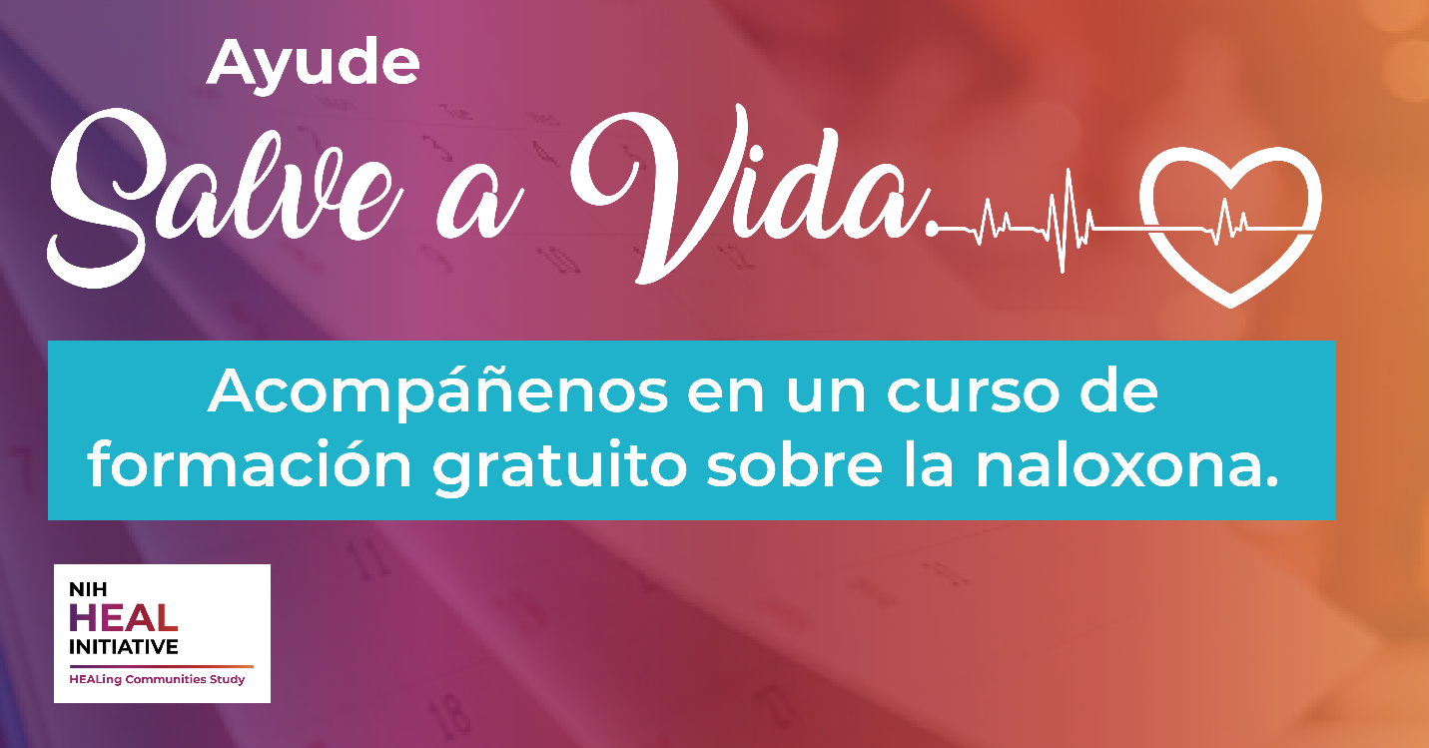

Social Media Content

Target Audience: Drug Users Who Know About and/or Seek Fentanyl
Post 1 in English
The street drug supply has always been unpredictable and inconsistent, especially now with #fentanyl contamination. Assume #overdose is possible no matter what drug you’re using and practice harm reduction strategies consistently to reduce #overdose risk.
Help save lives – carry #naloxone and learn how to use it: [insert HCS community vanity url]
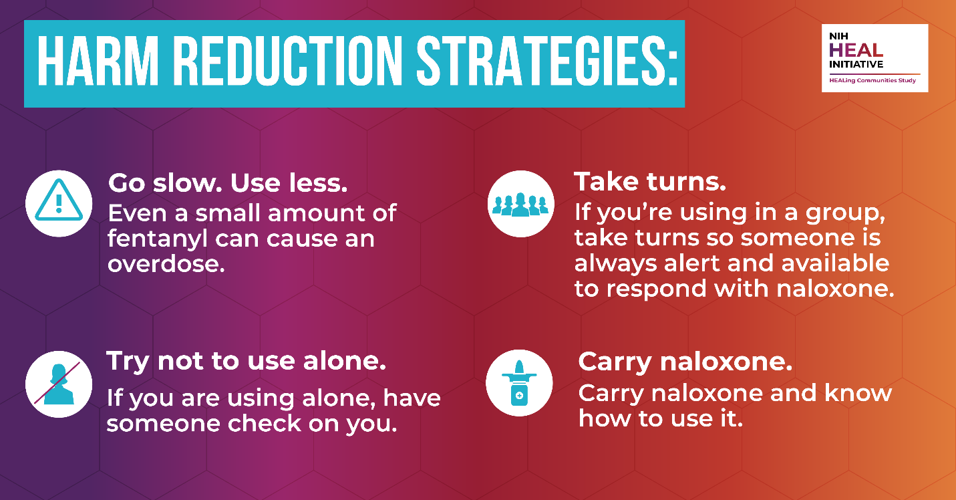

Post 1 in Spanish
El expendio de drogas callejero siempre ha sido impredecible e inconsistente, especialmente ahora con la contaminación por #fentanilo. Asuma que la #sobredosis es posible, independientemente de la droga que consuma, y practique estrategias de reducción de daños de forma sistemática para reducir el riesgo de #sobredosis.
Ayude a salvar vidas: lleve consigo #naloxona y aprenda a usarla: [insert HCS community vanity url]
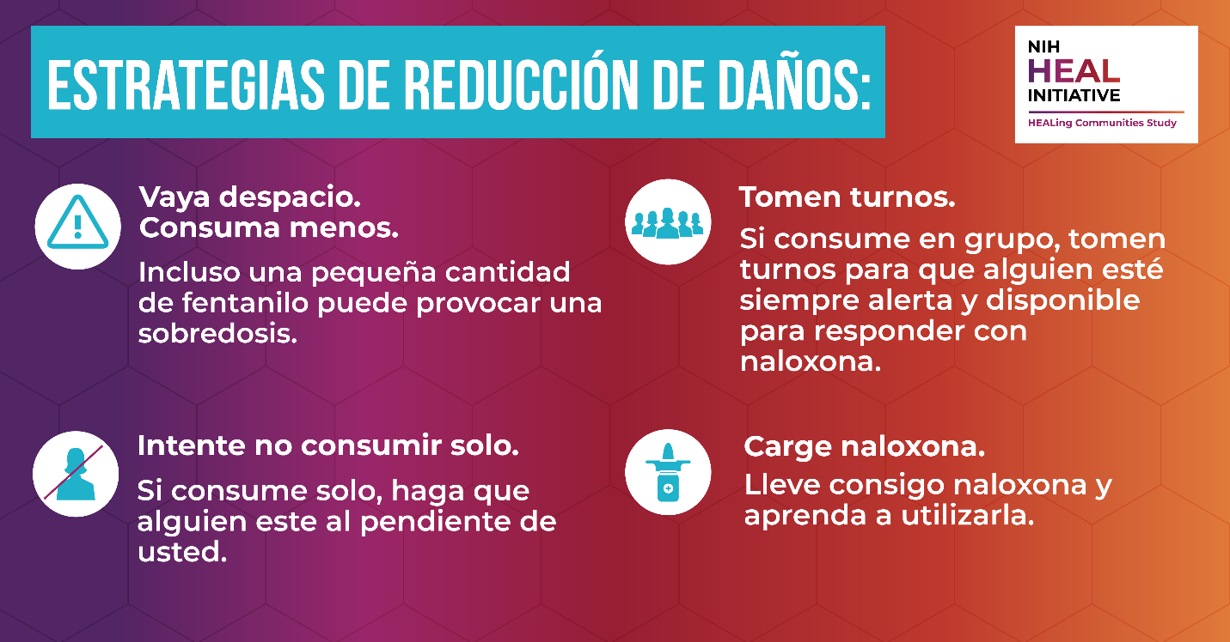

Post 2 in English
Recognizing an opioid #overdose can be difficult. If you aren’t sure, it is best to treat the situation like an overdose—you could save a life. Call 911 immediately Give them naloxone. Do not leave the person alone.
Help save lives – carry #naloxone and learn how to use it: [insert HCS community vanity url]
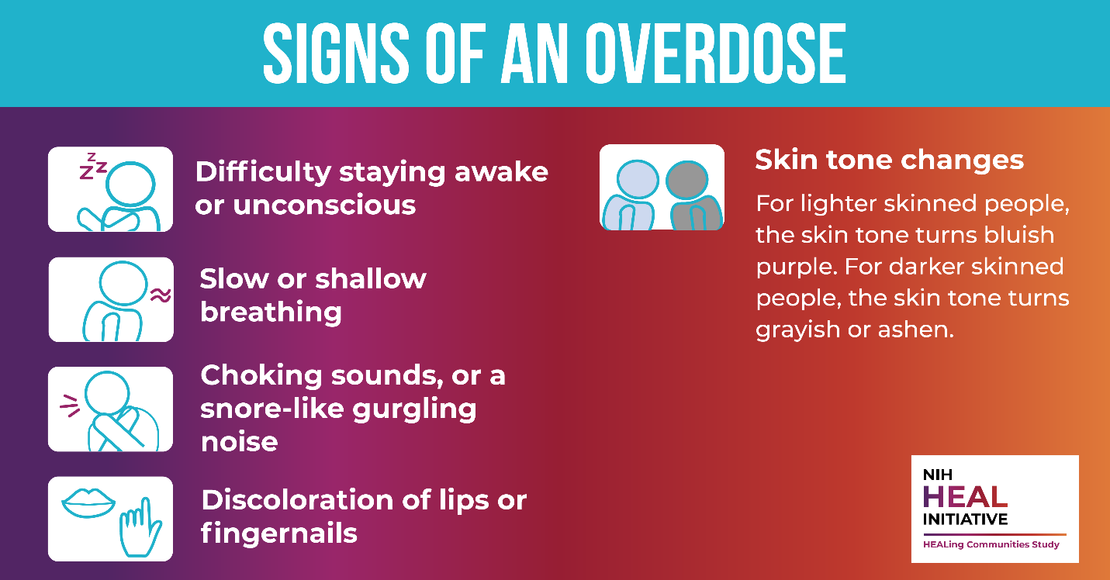
Post 2 in Spanish
Reconocer una #sobredosis de opioides puede ser difícil. Si no está seguro, lo mejor es tratar la situación como si fuera una sobredosis: podría salvar una vida. Llame al 911 inmediatamente y administre naloxona. No deje a la persona sola.
Ayude a salvar vidas: lleve consigo #naloxona y aprenda a usarla: [insert HCS community vanity url]
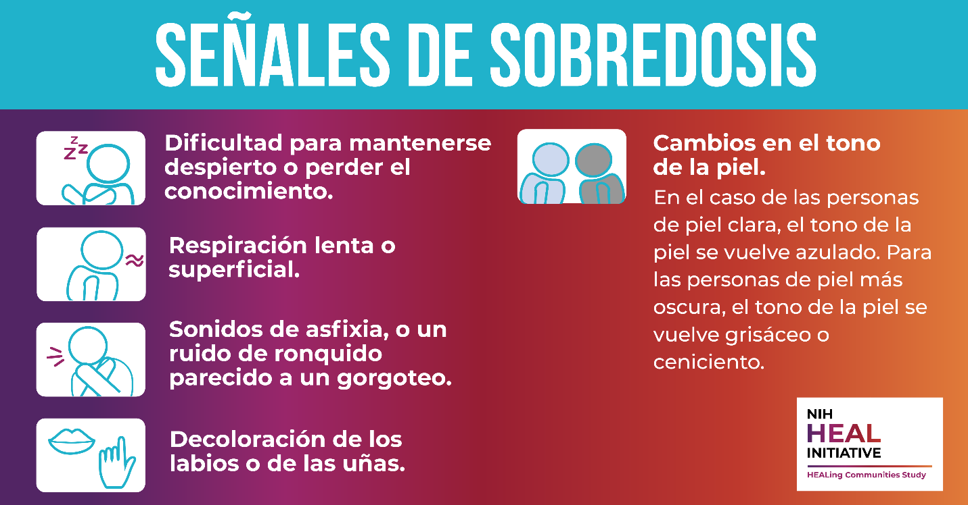

Post 3 in English
It may be hard to tell whether a person is high or experiencing an #overdose. If you aren’t sure, treat it as an #overdose and call 911 immediately and give naloxone—you could save a life!
Help save lives – carry #naloxone and learn how to use it: [insert HCS community vanity url]
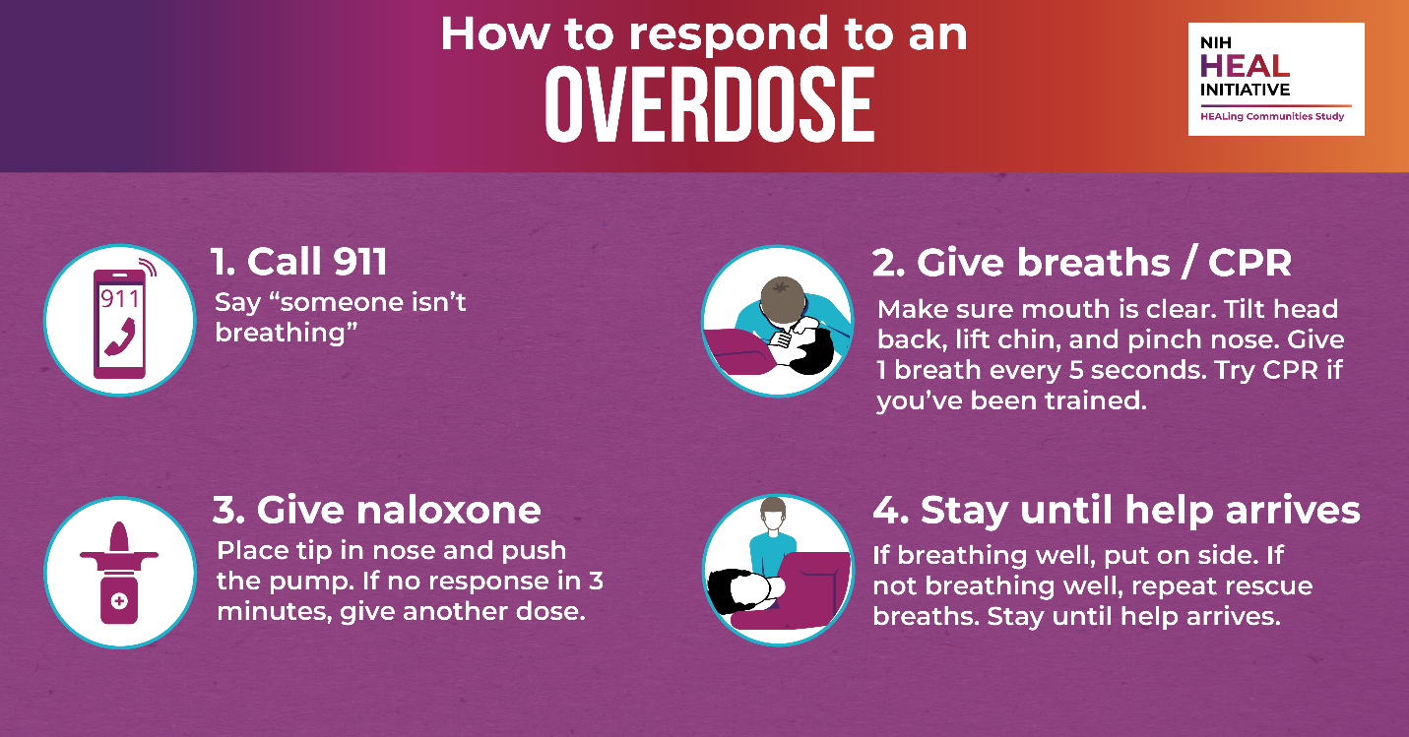

Post 3 in Spanish
Puede ser difícil saber si una persona está drogada o sufre una #sobredosis. Si no está seguro, trátelo como una #sobredosis, llame inmediatamente al 911 y administre naloxona: ¡podría salvar una vida! Ayude a salvar vidas: lleve consigo #naloxona y aprenda a usarla: [insert HCS community vanity url]
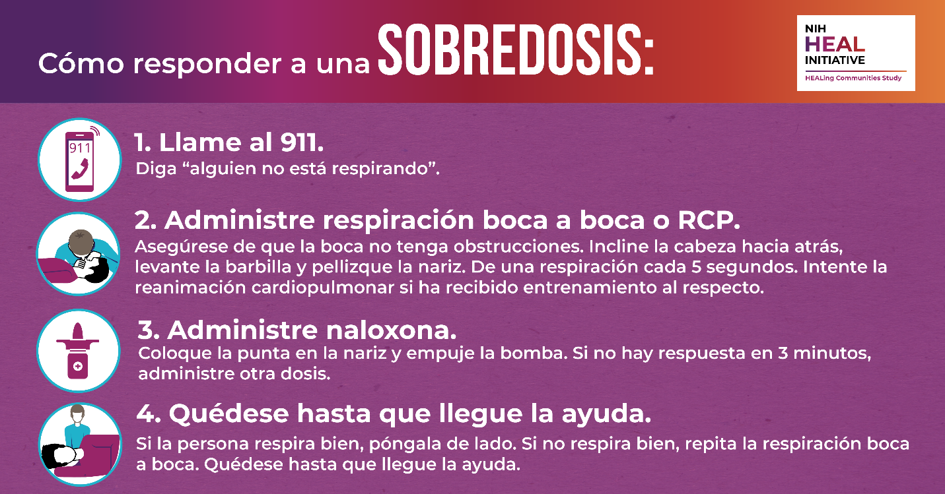

Post 4 in English
People who use counterfeit painkillers and benzodiazepines, heroin, cocaine, and methamphetamine, which may be contaminated with #fentanyl, are at risk for opioid #overdose. Help save lives – carry #naloxone and learn how to use it: [insert HCS community vanity url]

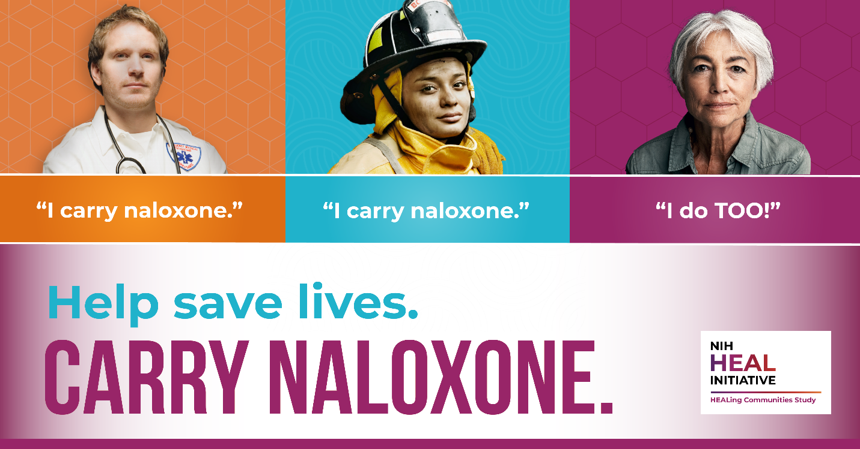

Post 4 in Spanish
Las personas que consumen analgésicos y benzodiacepinas falsificados, heroína, cocaína y metanfetaminaa, que pueden estar contaminados con #fentanilo, corren el riesgo de sufrir una #sobredosis de opioides.
Ayude a salvar vidas: lleve consigo #naloxona y aprenda a usarla: [insert HCS community vanity url]
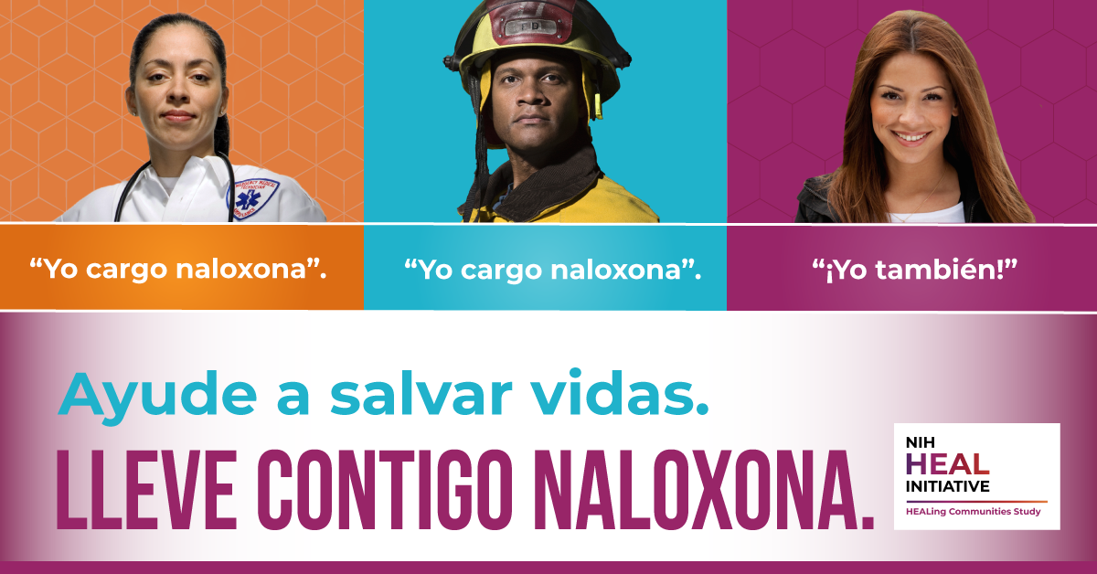

Post 5 in English
#PeopleWhoUseDrugs are in danger more than ever with the rise of #fentanyl contamination in street drugs. Your local syringe services program (SSP) has information and resources to help protect you from overdose. Help save lives – carry #naloxone and learn how to use it: [insert HCS community vanity url]
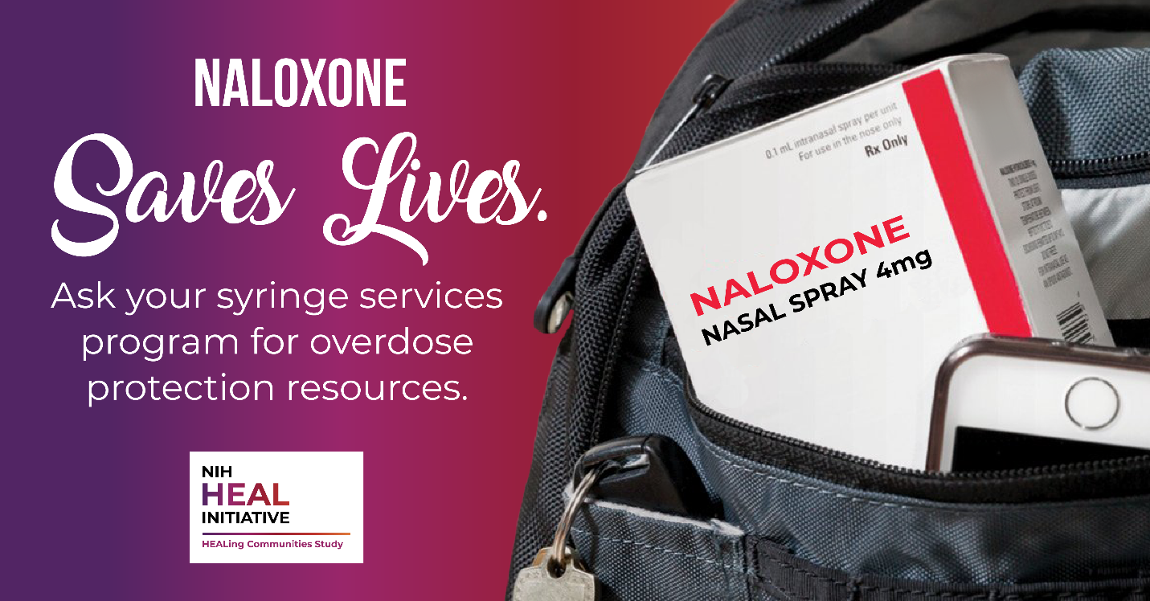

Post 5 in Spanish
Las #PersonasQueUsanDrogas están en más peligro que nunca con el aumento de la contaminación por #fentanilo en las drogas callejeras. Su programa local de servicios de jeringas (SSP) tiene información y recursos para ayudarle a protegerse de una sobredosis.
Ayude a salvar vidas: lleve consigo #naloxona y aprenda a usarla: [insert HCS community vanity url]
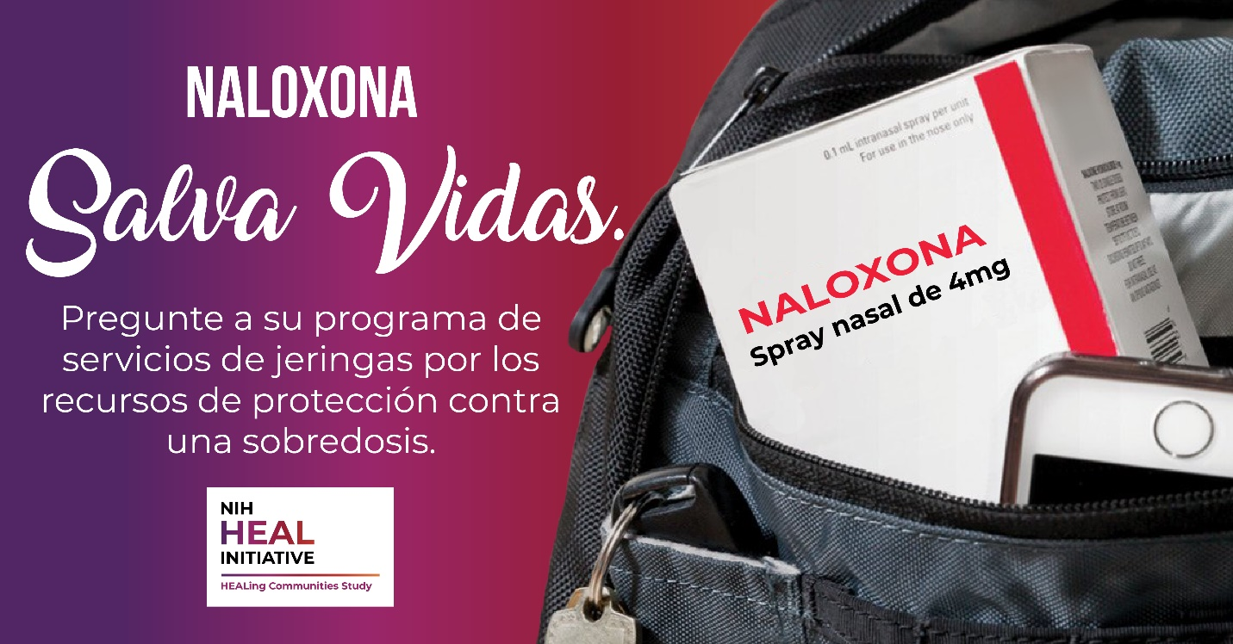
Post 6 in English
Anyone who uses drugs like #fentanyl, counterfeit painkillers and benzodiazepines, heroin, cocaine, and methamphetamine is at risk of #overdose. Naloxone, given as a nasal spray, can reverse overdose and save a life. Naloxone is available at your pharmacy without a prescription.
Help save lives – carry #naloxone and learn how to use it: [insert HCS community vanity url]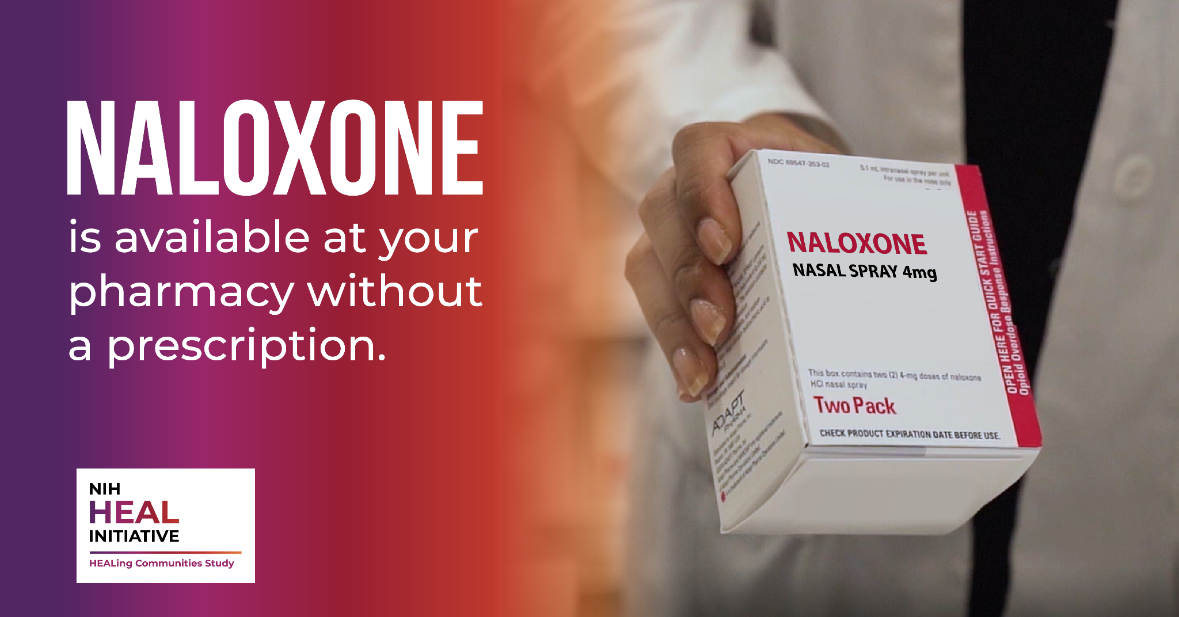

Post 6 in Spanish
Cualquiera que consuma drogas como el #fentanilo, analgésicos y benzodiacepinas falsificados, heroína, cocaína y metanfetaminas corre el riesgo de sufrir una #sobredosis. La naloxona, administrada en forma de spray nasal, puede revertir la sobredosis y salvar una vida. La naloxona está disponible en su farmacia sin receta médica.
Ayude a salvar vidas: lleve consigo #naloxona y aprenda a usarla: [insert HCS community vanity url]
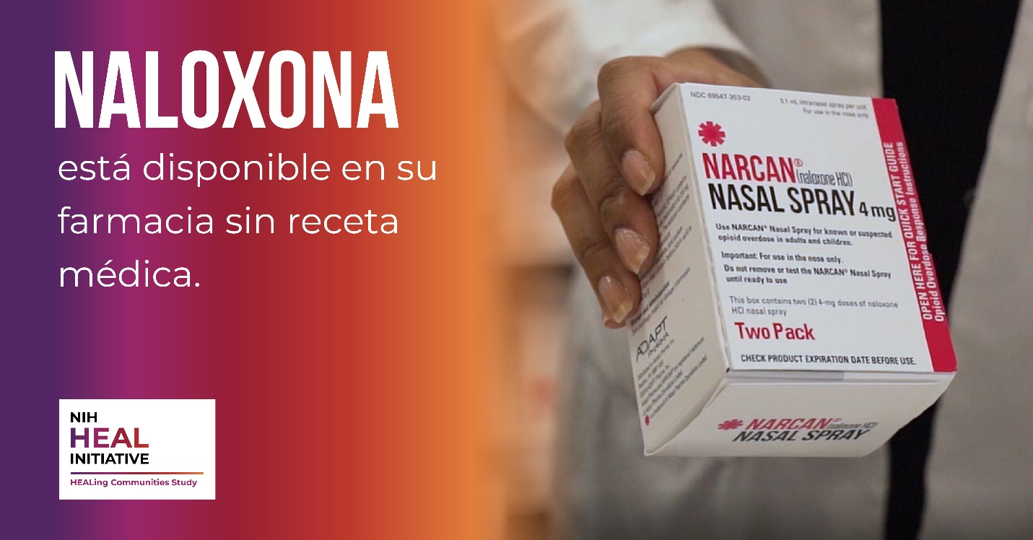
Post 7 in English
In just a few minutes, you can learn how to recognize the signs of an #overdose, give naloxone, and save a life! Mark your calendar, our next #naloxone training will be held on [insert date/time]. Help save lives – carry #naloxone and learn how to use it: [insert HCS community vanity url]

Post 7 in Spanish
¡En sólo unos minutos, puede aprender a reconocer las señales de una #sobredosis, administrar naloxona y salvar una vida! Marque su calendario, nuestro próximo curso de formación de #naloxona se llevará a cabo el [insertar fecha/hora].
Ayude a salvar vidas: lleve consigo #naloxona y aprenda a usarla: [insert HCS community vanity url]
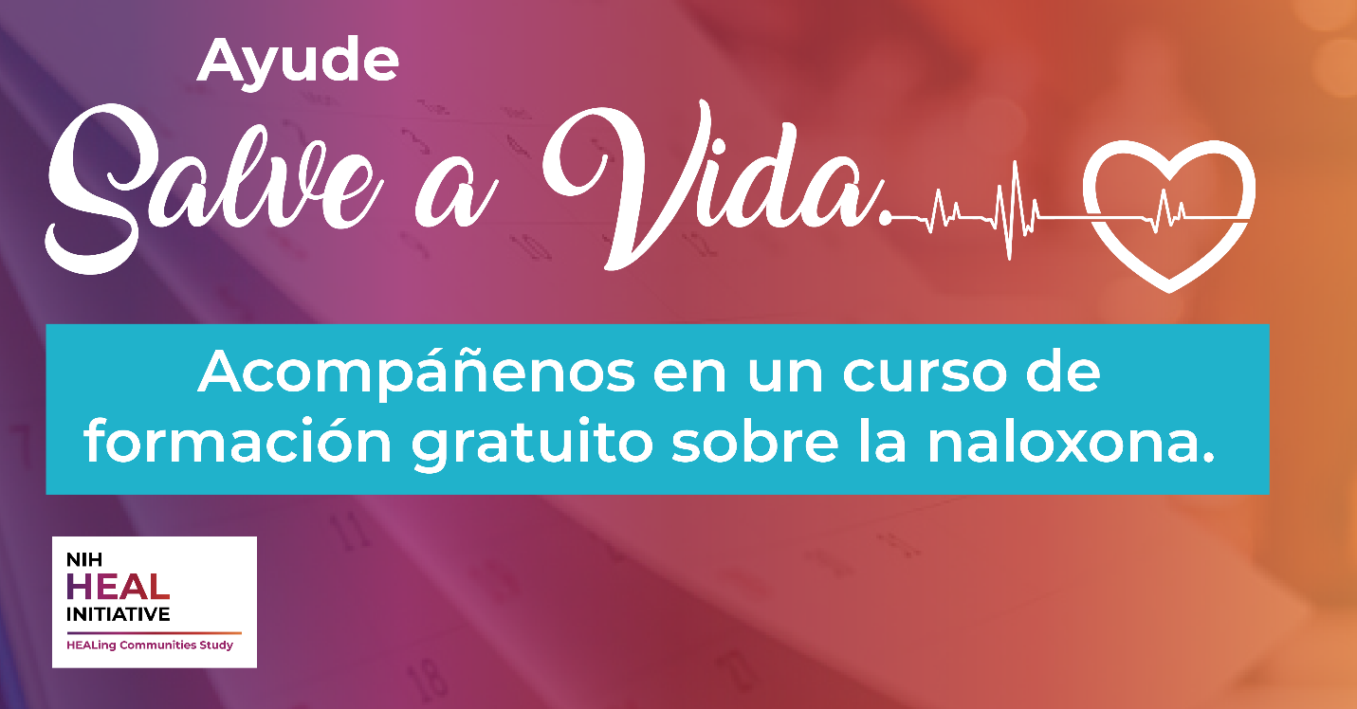
Post 8 in English

In 2021, #fentanyl became the leading cause of death of Americans 18-45 years old. If you or your loved ones use drugs like #fentanyl, counterfeit painkillers and benzodiazepines, heroin, cocaine, and methamphetamine, having naloxone with you and knowing how to use it could save a life.
Help save lives – carry #naloxone and learn how to use it: [insert HCS community vanity url]

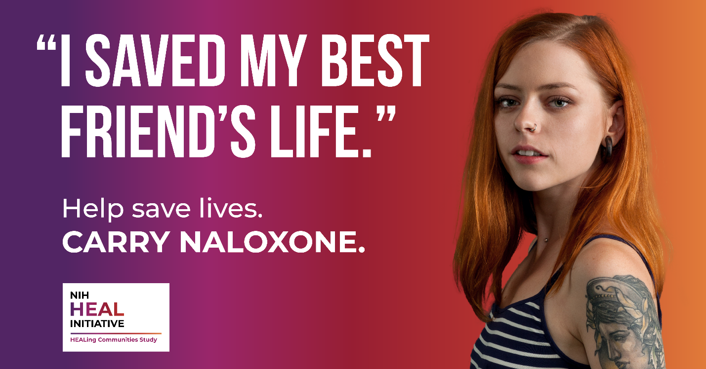

Post 8 in Spanish
En 2021, el #fentanilo se convirtió en la principal causa de muerte de los estadounidenses de entre 18 y 45 años. Si usted o sus seres queridos consumen drogas como el #fentanilo, analgésicos y benzodiacepinas falsificados, heroína, cocaína y metanfetaminas, cargar naloxona y saber cómo usarla podría salvar una vida.
Ayude a salvar vidas: lleve consigo #naloxona y aprenda a usarla: [insert HCS community vanity url]
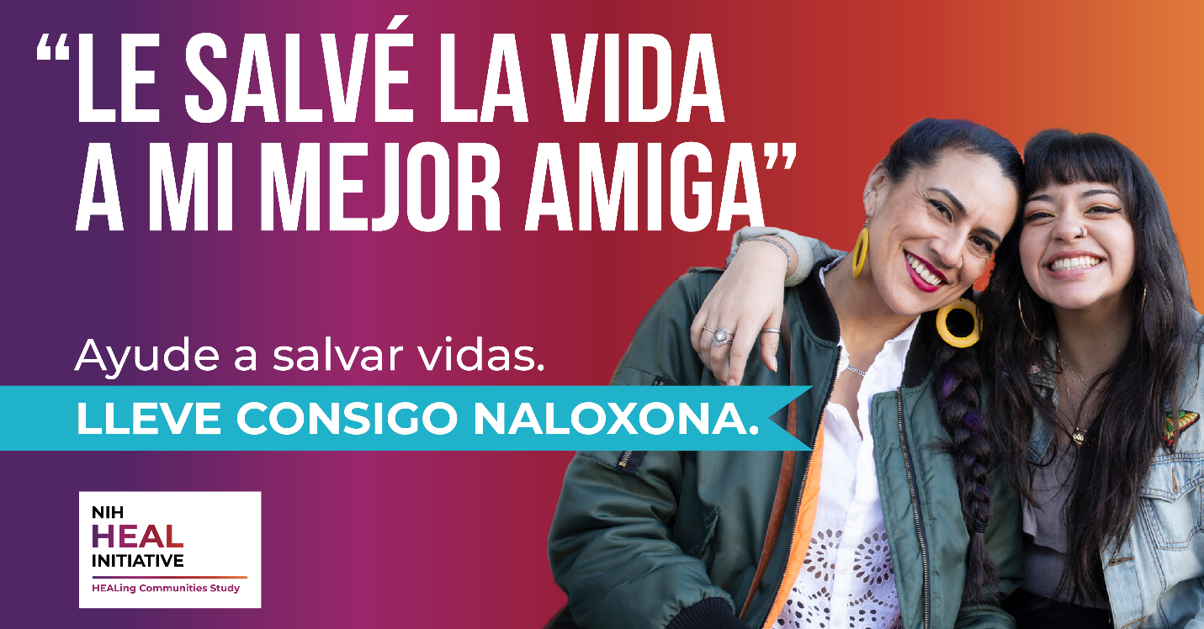

Post 9 in English
If you or your loved ones use drugs like #fentanyl, counterfeit painkillers and benzodiazepines, heroin, cocaine, and methamphetamine, stop an #overdose by calling 911, giving rescue breaths and naloxone, and staying until help arrives. Help save a life by following four steps to stop an overdose.
Help save lives – carry #naloxone and learn how to use it: [insert HCS community vanity url]

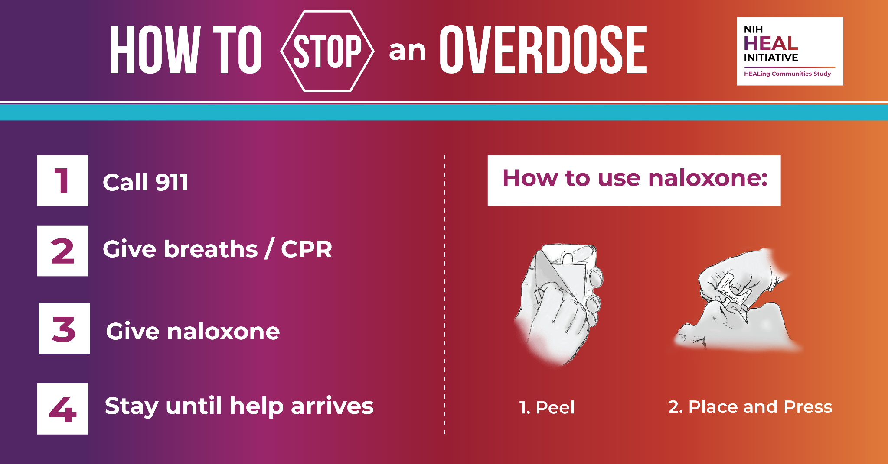

Post 9 in Spanish
Si usted o sus seres queridos consumen drogas como el #fentanilo, analgésicos y benzodiacepinas falsificados, heroína, cocaína y metanfetaminas, detenga una #sobredosis llamando al 911, administrando respiración boca a boca y naloxona, y permaneciendo hasta que llegue la ayuda. Ayude a salvar una vida siguiendo cuatro pasos para detener una sobredosis.
Ayude a salvar vidas: lleve consigo #naloxona y aprenda a usarla: [insert HCS community vanity url]
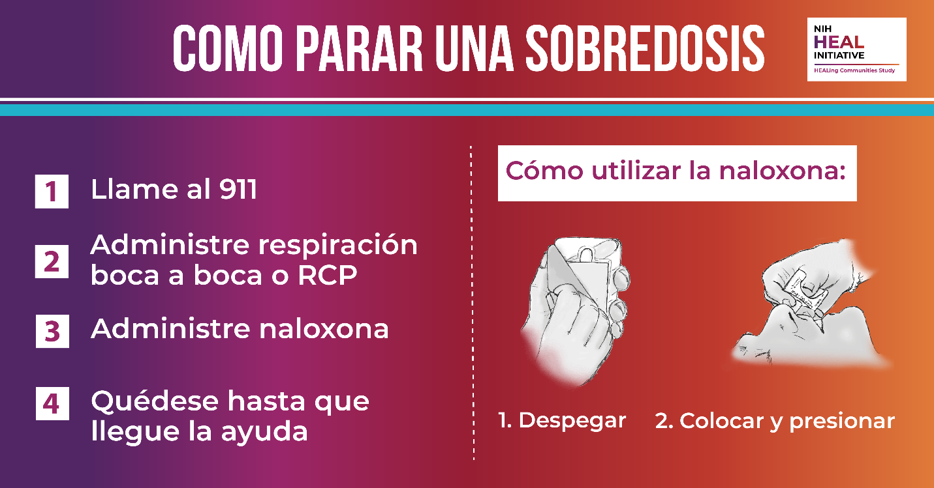

Sample Op-Ed in English
Fentanyl: The Current Wave of the Opioid Crisis in [insert name of community]
The United States has passed a grim, heartbreaking milestone: a record number of Americans are dying as a result of a drug overdose. Between April 2020 and April 2021, drugs – mostly synthetic opioids such as fentanyl – took the lives of more than 100,000 of our sons and daughters, loved ones and neighbors, community members, and friends. [Insert community specific data on fentanyl-related overdose deaths, if available].
This rise in opioid overdoses across the U.S. is largely due to illicit fentanyl contaminating street drugs. Pharmaceutical fentanyl is a synthetic opioid that is FDA-approved as a patch or lozenge for the treatment of severe pain. Fentanyl is at least 50 times more potent than heroin. Most recent cases of fentanyl-related harm, overdose, and death in the U.S. are linked to illegally made fentanyl that is mixed into drugs like counterfeit painkillers and benzodiazepines, heroin, cocaine, and methamphetamine.
Because we have an unregulated and criminalized drug supply, there is no way to tell if a street drug one is using is 100% safe. This means that someone may use a product that they believe their body is able to tolerate, but it may actually be much stronger than they expect due to being contaminated with fentanyl, without knowing.
The opioid crisis is not confined to a particular subset of our population. The epidemic affects wealthy and poor, Black and white, rural and urban, and every corner of [insert name of community].

HEALing Our Communities
The street drug supply has always been unpredictable and inconsistent – this is especially true now. Assume overdose risk no matter what drug you’re using, and practice as much harm reduction as possible, as consistently as possible:
- Go slow.
- Use less.
- Try not to use alone. If you do, have someone with naloxone check on you.
- If you’re using in a group, have naloxone on-hand and take turns so someone is always alert and available to respond.
- Know the signs of an overdose.
- Carry naloxone and know how to use it.
- Look out for others in the community and administer naloxone if you suspect an overdose!

By following these harm reduction strategies, together, we can HEAL our communities and reduce preventable overdose deaths.

More Information
To learn more about fentanyl and naloxone, visit [insert HCS community vanity url].

Sample Op-Ed in Spanish
Fentanilo: La ola actual de la crisis de los opioides en [inserte el nombre de la comunidad]
Estados Unidos ha superado un hito sombrío y desgarrador: un número récord de estadounidenses mueren a causa de una sobredosis de drogas. Entre abril de 2020 y abril de 2021, las drogas, en su mayoría opioides sintéticos como el fentanilo, cobraron la vida de más de 100,000 de nuestros hijos e hijas, seres queridos y vecinos, miembros de la comunidad y amigos.
Este aumento de las sobredosis de opioides en los Estados Unidos se debe en gran medida a que el fentanilo ilícito contamina las drogas callejeras. El fentanilo farmacéutico es un opioide sintético aprobado por la FDA en forma de parches o pastillas para el tratamiento del dolor intenso. El fentanilo es al menos 50 veces más potente que la heroína. Los casos más recientes de daños, sobredosis y muertes relacionadas con el fentanilo en Estados Unidos están relacionados con el fentanilo fabricado ilegalmente que se mezcla con drogas como analgésicos y benzodiacepinas falsificados, heroína, cocaína y metanfetaminas.
Debido a que tenemos un suministro de drogas no regulado y criminalizado, no hay manera de saber si la droga de la calle que uno está usando es 100% segura. Esto significa que alguien puede utilizar un producto que cree que su cuerpo es capaz de tolerar, pero en realidad puede ser mucho más fuerte de lo que espera debido a que está contaminado con fentanilo, sin saberlo.
La crisis de los opioides no se limita a un subconjunto concreto de nuestra población. La epidemia afecta a ricos y pobres, blancos y negros, zonas rurales y urbanas, y a todos los rincones de [inserte el nombre de la comunidad].
Sanar nuestras comunidades

El suministro de drogas callejeras siempre ha sido impredecible e inconsistente, y esto es especialmente cierto ahora. Se debe asumir el riesgo de sobredosis independientemente de la droga que se consuma y se debe practicar la mayor prevención de riesgos posible, con la mayor constancia posible:
- Vaya despacio.
- Consuma menos.
- Intente no consumir solo. Si consume solo, haga que alguien este al pendiente de usted.
- Si se consume en grupo, hay que tener naloxona a la mano y tomar turnos para que alguien esté siempre alerta y disponible para responder.
- Conozca las señales de una sobredosis.
- Lleve consigo naloxona y sepa cómo utilizarla.
- ¡Esté pendiente de los demás en la comunidad y administre naloxona si sospecha una sobredosis!
Siguiendo estas estrategias de reducción de daños, juntos podemos SANAR a nuestras comunidades y reducir las muertes por sobredosis evitables.
Más información
Para saber más sobre el fentanilo y la naloxona, visite: [insert HCS community vanity url].

Sample Partner Support Email in English
PURPOSE: Send this to partner organizations in your community to secure their support in sharing campaign content.

HINT: Review your campaign dissemination plan to identify suitable partners with existing relationships, networks, and channels to help you reach specific priority audience groups and segments.

NOTE: The HCS campaign timeline is long in duration to account for research site and community-wide variations in campaign start dates, paid media plans, etc. Campaigns that are too long (e.g., longer than 2 months) have a hard time maintaining momentum, especially among partner organizations and community champions. Therefore, we recommend asking partners to share campaign materials at the same time across a specific, smaller timeline (e.g., March 2022) to maximize partner support and increase exposure and engagement among the priority audience groups.

Subject: HCS-[Community] Launches New Campaign

Dear [INSERT NAME],
The HEALing Communities Study-[Insert name of community] is excited to announce the launch of a new education campaign that will support study efforts to reduce opioid overdose-related deaths in our community. The campaign aims to educate the community about the dangers of illicit fentanyl, the availability of naloxone and its ability to reverse overdoses, and that anyone can administer naloxone to save lives. The campaign will run from February 25, 2022 to June 29, 2022.
I’m reaching out to you today because you are a valuable partner, and we need your support to reach [insert specific priority audience group or segment, if applicable] throughout March 2022. By working together we can amplify the campaign here in [insert name of community] and help reduce overdose deaths.
Partnering and support can take many forms. It could mean disseminating campaign materials and messages through your communication channels (website, social media, newsletter, etc.), promoting the campaign at meetings and events, and participating in interviews in local media outlets, just to name a few. You can visit our online partner toolkit for sample social media posts, graphics, and more.
Can we count on [INSERT NAME OF ORGANIZATION] support for our campaign? If so, please respond and let me know how I can help.
If you have any questions or need any additional information or materials, please contact [INSERT NAME] at [INSERT PHONE NUMBER] or email at [INSERT EMAIL].
Thank you in advance for your help HEALing our Community!
INSERT NAME
INSERT TITLE
INSERT NAME OF COMMUNITY COALITION

Sample Partner Support Email in Spanish
Subject: HCS-[insert name of community] lanza una nueva campaña
Estimado [insert name],
El estudio HEALing Communities-[insert the name of the community] se complace en anunciar el lanzamiento de una nueva campaña educativa que apoyará los esfuerzos del estudio para reducir las muertes relacionadas con la sobredosis de opioides en nuestra comunidad. La campaña pretende educar a la comunidad sobre los peligros del fentanilo ilícito, la disponibilidad de la naloxona y su capacidad para revertir las sobredosis, y el hecho que cualquier persona puede administrar la naloxona para salvar vidas. La campaña se desarrollará del 25 de febrero de 2022 al 29 de junio de 2022.
Me comunico con usted hoy porque es un socio valioso y necesitamos su apoyo durante el mes de marzo de 2022.
Trabajando juntos podemos dar un mayor alcance a la campaña aquí en [insert name of community] y ayudar a reducir las muertes por sobredosis.
La asociación y el apoyo pueden concretarse de muchas maneras. Podría significar la difusión de materiales y mensajes de la campaña a través de sus canales de comunicación (sitio web, redes sociales, boletín informativo, etc.), la promoción de la campaña en reuniones y eventos, y la participación en entrevistas en los medios de comunicación locales, por nombrar sólo algunos. Puede visitar nuestro kit de herramientas en línea para socios para ver ejemplos de publicaciones en redes sociales, gráficos y más.
¿Podemos contar con su apoyo para nuestra campaña? Si es así, por favor responda y hágame saber cómo puedo ayudar.
Si tiene alguna pregunta o necesita información o material adicional, póngase en contacto con [insert your name] en el [insert pone number] o por correo electrónico en [insert email].

¡Gracias de antemano por su ayuda para sanar nuestra comunidad a través de HEALing Communities!
Insert your name

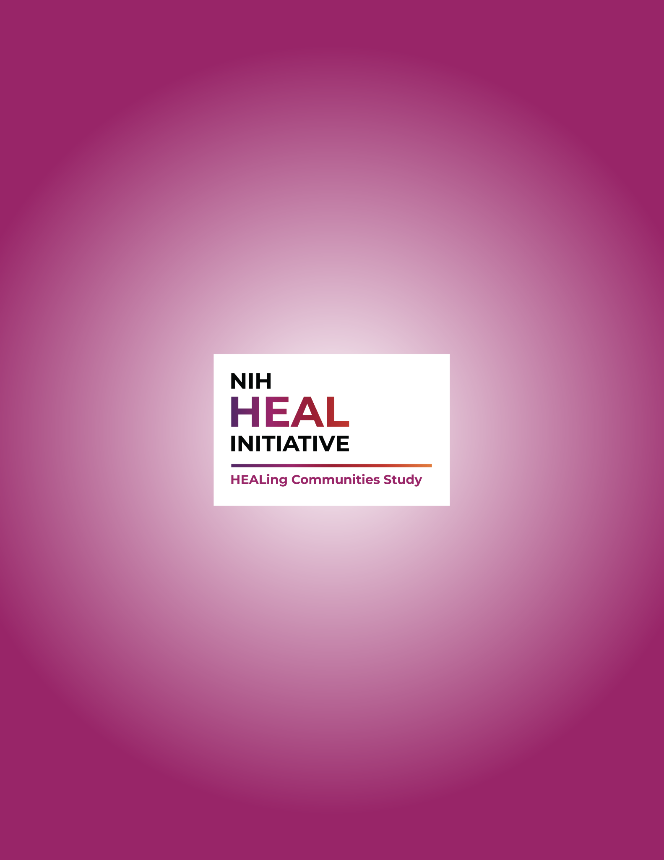

Ahmad FB, Rossen LM, Sutton P. Provisional drug overdose death counts. National Center for Health Statistics. 2022. Retrieved 1/27/22 from: https://www.cdc.gov/nchs/nvss/vsrr/drug-overdose-data.htm

