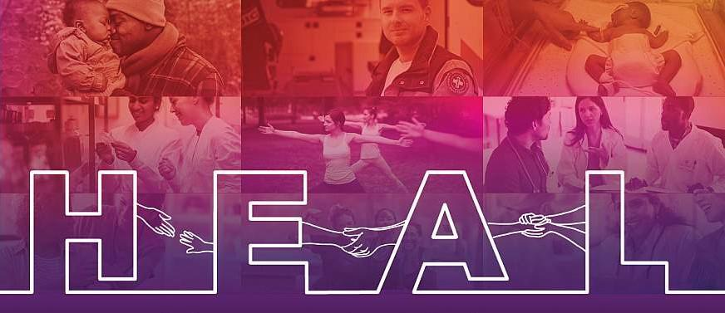

Communities That HEAL

# DISTRIBUTION TOOLKIT

## *Wave One, Campaign Three: Medications for Opioid Use Disorder (MOUD) Awareness*

## October 2020 – December 2020

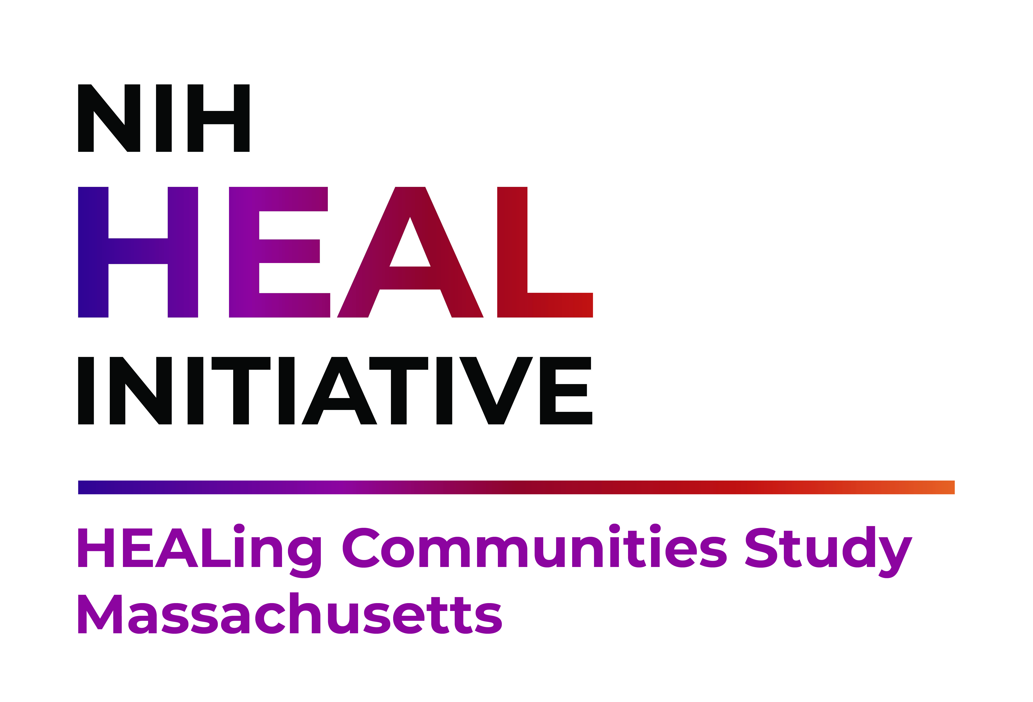

**Table of Contents**

About the Toolkit 1

Project Overview 3

Campaign Overview 4

Key Messages and Calls to Action 6

Sample Social Media Copy 7

Target Audience: Community Leaders 7

Target Audience: Providers 9

Target Audience: People with Lived Experience 11

COVID-19 Focused Posts 13

Partner Engagement Outreach 15

Sample PSA Scripts 17

# 

# About the Toolkit

## Purpose

This Toolkit serves as a guide to help Communities That HEAL Wave One communities disseminate the *Medications for Opioid Use Disorder (MOUD) Awareness* campaign from October 2020 – December 2020 and includes:

* An updated campaign overview
* Suggested social media content
* Sample resources that can be tailored by the community

# Campaign Material Toolbox

A Campaign Material Toolbox has been developed for Wave One communities. The online toolbox contains all of the tailored campaign materials for each community in one folder. Campaign materials can easily be downloaded, and printed or electronically disseminated.

To download campaign materials, visit <https://www.cthcampaigntoolbox.com/massachusetts> and click on your community’s specific toolbox link. If you have requests for additional campaign materials or graphics, you can email Dacia Beard at [beardd@bu.edu](mailto:beardd@bu.edu).

# Campaign Tracking

Help us track campaign activities and improve future campaigns by completing the campaign tracking form which can be accessed via you community’s toolbox, or directly through the following links:

[Bourne and Sandwich](https://drive.google.com/file/d/1EMkbxcQV2YOgvB7faXugbKap8jYpQz6q/view?usp=sharing)

[Brockton](https://drive.google.com/file/d/1z6EvdWcp1YrdmM3N1EXNF6u0LvZfZ_45/view?usp=sharing)

[Gloucester](https://drive.google.com/file/d/1T-5KmxtCg8erBk1zvOOpwVMZRc-IJ8bi/view?usp=sharing)

[Holyoke](https://drive.google.com/file/d/1ZYkNWkDYNgFDadLzNP3R3Lptsfi7GvQj/view?usp=sharing)

[Lowell](https://drive.google.com/file/d/1LnOY1rb0nOYL6hl8VzXd3pCahLl2wAX-/view?usp=sharing)

[Plymouth](https://drive.google.com/file/d/1KjroZ2_daeEZcqQBzONnG7m1oND6TPkr/view?usp=sharing)

[Salem](https://drive.google.com/file/d/1yzgqStZhxMtT-dvAauY9xZjb9IYc-M3q/view?usp=sharing)

[Shirley and Townsend](https://drive.google.com/file/d/1RKqISNGaj2U1pgv6c9By5iv3J_b5VRwJ/view?usp=sharing)

# Vanity URLs

**PURPOSE:** Use your community’s vanity URL where applicable to navigate the end-user to the HCS website.

**Bourne and Sandwich**

[www.HealTogetherMA.org/Barnstable](http://www.HealTogetherMA.org/Barnstable)

**Brockton**

[www.HealTogetherMA.org/Brockton](http://www.HealTogetherMA.org/Brockton)

**Gloucester**

[www.HealTogetherMA.org/Gloucester](http://www.HealTogetherMA.org/Gloucester)

**Holyoke**

[www.HealTogetherMA.org/Holyoke](http://www.HealTogetherMA.org/Holyoke)

**Lowell**

[www.HealTogetherMA.org/Lowell](http://www.HealTogetherMA.org/Lowell)

**Plymouth**

[www.HealTogetherMA.org/Plymouth](http://www.HealTogetherMA.org/Plymouth)

**Salem**

[www.HealTogetherMA.org/Salem](http://www.HealTogetherMA.org/Salem)

**Shirley and Townsend**

[www.HealTogetherMA.org/Middlesex](http://www.HealTogetherMA.org/Middlesex)

# 

# Project Overview

## Background

Communities across the United States are dealing with the catastrophic consequences of excessive availability and use of prescription opioids, illicit opioids such as heroin, and manufactured fentanyl and related analogs. Millions of Americans are struggling with inappropriate use of opioids and opioid use disorder (OUD). In fact, Massachusetts is ranked among the top 10 states with the highest rates of opioid overdose deaths.

Evidence-based practices (EBPs) to address opioid use disorder and overdose exist, including opioid overdose education and naloxone distribution (OEND) programs; strategies to reduce inappropriate opioid prescribing; FDA-approved medications for opioid use disorder (MOUD), including methadone, buprenorphine, Suboxone® (buprenorphine and naloxone), naltrexone, and Vivitrol® (injectable naltrexone); behavioral therapies; and recovery support services. One driver of the opioid crisis is the gap between the number of individuals who could benefit from these EBPs and those actually engaged in care. The National Survey on Drug Use and Health (NSDUH) estimates that 2.1 million Americans have OUD, yet fewer than 20% of those individuals receive specialty care in a given year.

In partnership with your community, Boston Medical Center is participating in the HEALing Communities Study (HCS) to bridge this gap and reduce opioid-related overdose deaths by 40 percent over the course of three years. Working together, we know we can change practices, culture, and stigma that lead to opioid overdose deaths every day.

# Campaign Overview

## About the Campaign

To achieve the goal of reducing opioid-related overdose deaths by 40 percent over the course of three years, a core component of the HCS intervention is a series of community-based health communication campaigns, which include the following focus topics and distribution timelines:

|  |  |  |
| --- | --- | --- |
| **Campaign** | **Focus Topic** | **Distribution Timeline** |
| 1 | Naloxone (Narcan®) | April – June 2020 |
| 2 | Stigma toward medications for opioid use disorder (“Stigma”) | July – October 2020 |
| 3 | MOUD Awareness | October – December 2020 |
| 4 | Stay in MOUD treatment | January – April 2021 |
| 5 | *To be determined* | *To be determined* |

The content and information in this Toolkit support the distribution of Campaign 3: MOUD Awareness materials.

## Objectives

This campaign aims to achieve the following objectives:

* Increase demand for, access to, and availability of MOUD
* Increase MOUD prescribing

## Stigma Targets

The campaign aims to combat stigma by promoting the following:

* MOUD is not replacing one drug with another
* MOUD is an effective treatment for opioid use disorder (OUD)
* Using MOUD is real recovery

## Priority Groups

This campaign aims to target the following groups:

* **Community Leaders**
  + Elected officials (mayor, city council members, aldermen, sheriff, school board supervisors)
  + Opinion leaders (faith-based leaders, civic leaders, employers)
* **Healthcare Providers**
  + Primary care practitioners
  + Nurse prescribers
  + Pharmacists
  + First responders
  + Dentists
  + Referral sources (employee assistance programs, jails, administrators)
* **People with Lived Experience**
  + People with OUD
  + Loved ones of people with OUD
  + People in recovery

# Key Messages and Calls to Action

The key messages and calls to action listed below were developed based on findings from formative research and best practices in health communications. Use the following messages when developing new materials or accompanying provided campaign materials (e.g., social media graphics) to ensure campaign distribution activities are clear, consistent, and evidence-based.

|  |  |  |
| --- | --- | --- |
| **Priority Group** | **Key Messages** | **Calls to Action** |
| **Community Leaders** | * Medications for opioid use disorder save lives. * Medications for opioid use disorder work. * Buprenorphine works. * Methadone works. * Naltrexone works. | * Learn more about medications for opioid use disorder available in our community. |
| **Providers** | * Medications for opioid use disorder save lives. * Buprenorphine and methadone treatment decrease mortality by 50% in patients with OUD. * Buprenorphine and methadone help patients manage symptoms and achieve long-term remission and recovery. * Patients who stay in MOUD treatment, as long as they need to, have a decreased risk of mortality. | * Learn more about medications for opioid use disorder. |
| **People with Lived Experience** | * Life-saving medications for opioid use disorder are a path to recovery. * Buprenorphine is a path to recovery from opioid use disorder. * Methadone is a path to recovery from opioid use disorder. * Naltrexone is a path to recovery from opioid use disorder. | * Learn more about medications for opioid use disorder available in our community. |

# Sample Social Media Copy

**PURPOSE:** Sample copy for social media posts is provided below. Edit the sample copy as needed to meet the unique needs of your community and desired social media platform.

**HASHTAGS**: We encourage you to include hashtags in your posts to increase engagement. Consider including hashtags in each post (we recommend 1-2 hashtags on Facebook and 3-5 on Instagram). Possible hashtags include:

#HealTogetherMA, #CommunityName, #MOUDisrealrecovery, #MOUDworks, #Bupeworks, #methadoneworks, #naltrexoneworks, #opioidusedisorder

You can also create custom hashtags to help you monitor when and how your partners share campaign content. We recommend that you ask partners to share the posts publicly not privately, so they are visible when you pull the list.

## 

## Target Audience: Community Leaders

**Post 1:**

What are medications for opioid use disorder (MOUD)? Three medications are approved by the FDA to treat #opioidusedisorder – methadone, buprenorphine, and naltrexone. #HealTogetherMA

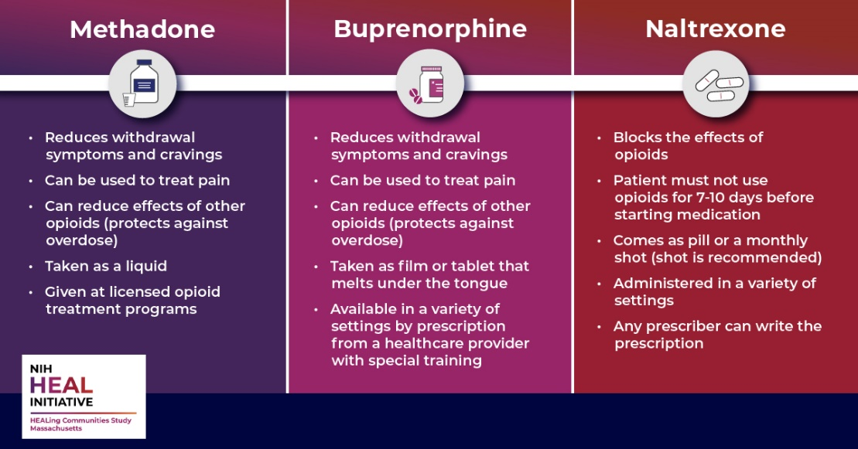

**Post 2:**

When someone is treated with medications for opioid use disorder (MOUD), it does not substitute one drug for another. Methadone and buprenorphine help reduce opioid cravings and withdrawal. These medications restore balance to the brain circuits affected by addiction, allowing the patient’s brain to heal while working toward recovery. ([National Institute on Drug Abuse, 2016](https://www.drugabuse.gov/publications/effective-treatments-opioid-addiction)) [Insert HCS community specific link; e.g., HEALTogetherMA.org/Salem]

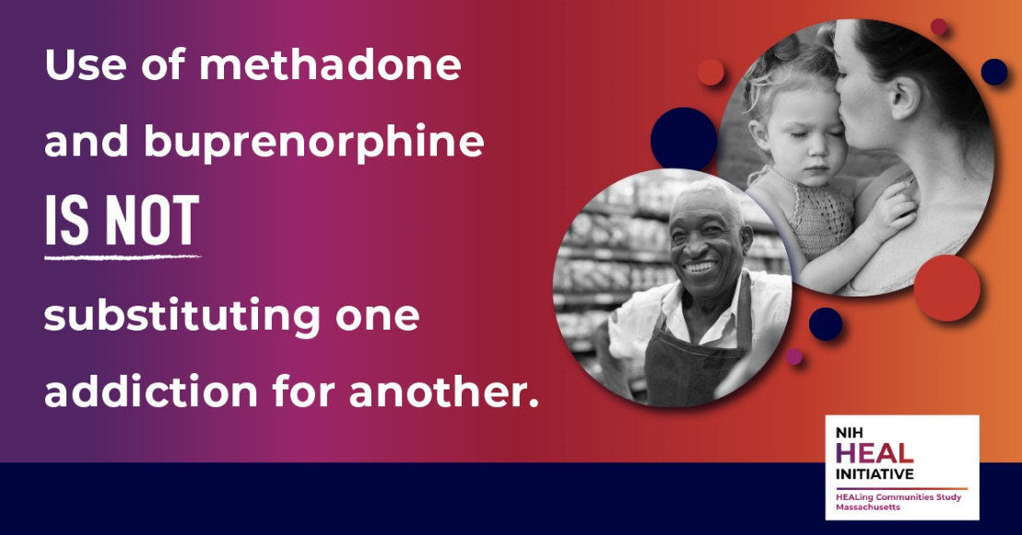

**Post 3:**

Why do we recommend medications for opioid use disorder (MOUD)? Because they save lives! People who stop using opioids often relapse (return to use) without medication to help them. Stopping and then restarting opioid use increases the chance of dying from an overdose. MOUD lowers the risk of relapse and death. [Insert HCS community specific link; e.g., HEALTogetherMA.org/Salem] #HealTogetherMA

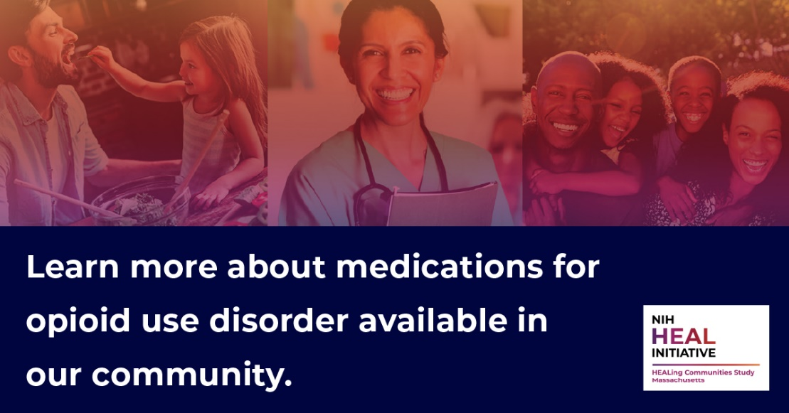

**Post 4:**

Why do we recommend medications for opioid use disorder (MOUD)? Because they save lives! Methadone and buprenorphine treatment decrease mortality by 50% in patients with OUD. These meds also help patients manage symptoms and achieve long-term remission and recovery. Learn more: [Insert HCS community specific link; e.g., HEALTogetherMA.org/Salem] #BupeWorks #MethadoneWorks

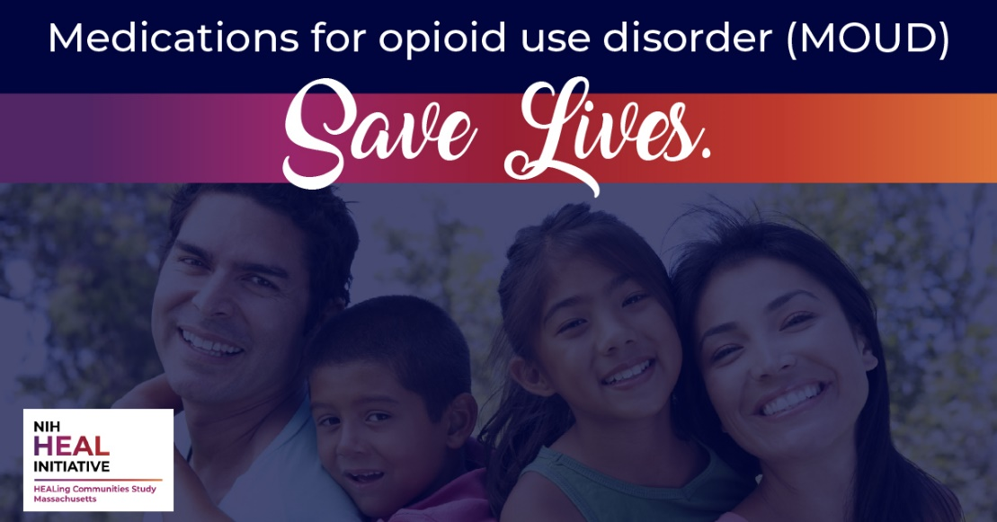

**Post 5:**

Each person has their own path to recovery from #opioidusedisorder, but research shows that medications for opioid use disorder (MOUD) offer the most effective treatment. Start your path to recovery here: [Insert HCS community specific link; e.g., HEALTogetherMA.org/Salem] #recoveryispossible #MOUDisrealrecovery #MOUDworks

## 

## Target Audience: Providers

**Post 6:**

It is the clinical standard of care to discuss medications that treat #opioidusedisorder with patients who have this disorder. Healthcare providers, discuss the facts below with your patients and help save lives!

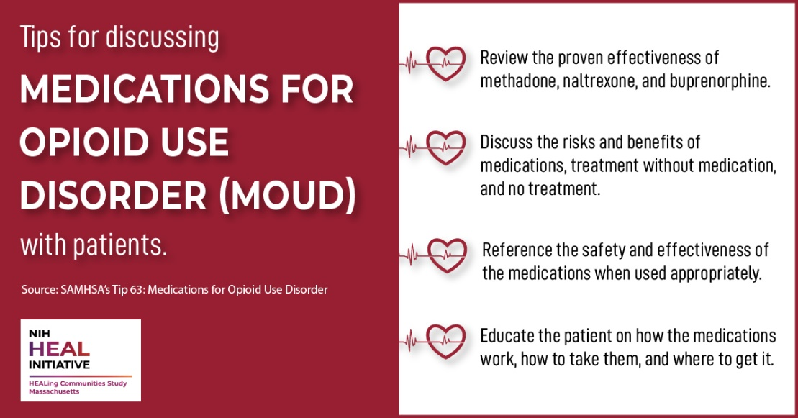

**Post 7:**

Treating opioid use disorder with medication is an evidence-based, life-saving practice. Yet, less than half of treatment programs offer medications for #opioidusedisorder. Learn how you can help provide or refer to medication treatment and decrease overdose deaths in [Insert community name]: [Insert HCS community specific link; e.g., HEALTogetherMA.org/Salem]

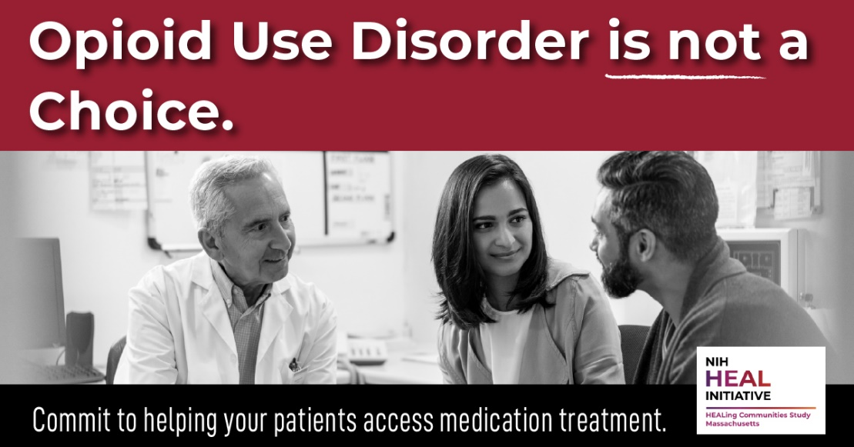

**Post 8:**

Qualifying physicians, NPs, and PAs can prescribe buprenorphine if they receive special training, obtain a SAMHSA waiver under DATA 2000, and get a unique Drug Enforcement Administration registration number. Until October 1, 2023, clinical nurse specialists, certified registered nurse anesthetists, and certified nurse midwives also are waiver-eligible to prescribe buprenorphine.([Source: SAMHSA’s Tips 63: Medications for Opioid Use Disorder](https://store.samhsa.gov/product/TIP-63-Medications-for-Opioid-Use-Disorder-Full-Document/PEP20-02-01-006)) Search here for more information about waiver trainings in our community: [insert state or local resource. Note: the HCS website does not currently include information about waiver training].

## 

## Target Audience: People with Lived Experience

**Post 9:**

Three medications are FDA-approved for treatment of opioid use disorder. They lower the risk of relapse and death and can help you stay in treatment longer. There are important differences in these medications, so talk to your doctor about which one would work best for you. Learn more: [Insert HCS community specific link; e.g., HEALTogetherMA.org/Salem] #HealTogetherMA



**Post 10:**

If your loved one struggles with #opioidusedisorder, help them seek the life-saving care they need to treat their chronic disease. Opioid use disorder can be managed with medication. Learn more about medications for opioid use disorder available in our community. [Insert HCS community specific link; e.g., HEALTogetherMA.org/Salem]

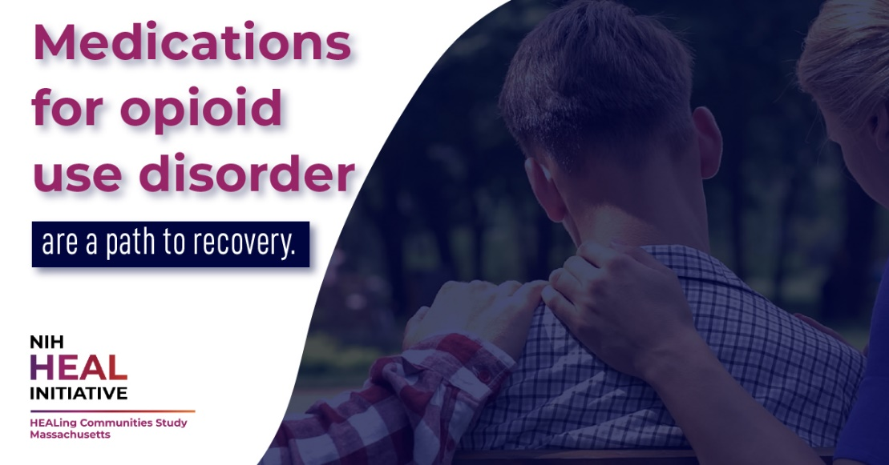

**Post 11:**

If you are one of the millions of Americans suffering from an #opioidusedisorder, there is hope.

Methadone and buprenorphine reduce withdrawal symptoms and cravings, helping you focus on the things that matter most. Learn how to make life-saving medications part of your path to recovery: [Insert HCS community specific link; e.g., HEALTogetherMA.org/Salem] #recoveryispossible #HealTogetherMA

## 

## COVID-19 Specific Content

**Post 12:**

5 Ways to Support People with an Opioid Use Disorder during the COVID-19 Pandemic

1. Get trained and carry naloxone (Narcan®) to reverse an overdose. Learn where: [Insert HCS community specific link; e.g., HEALTogetherMA.org/Salem]

2. Call them. Offer compassion, encouragement, and support.

3. Encourage them to seek medication treatment and to seek prevention services at a local syringe services or harm reduction program. [Insert link to local community SSP or harm reduction programs and hours, if applicable]

4. Encourage those already in treatment to stay engaged by calling their provider to ask about telehealth appointments in order to continue their medication for opioid use disorder and counseling/other recovery support services.

5. Connect them with organizations offering virtual recovery support.

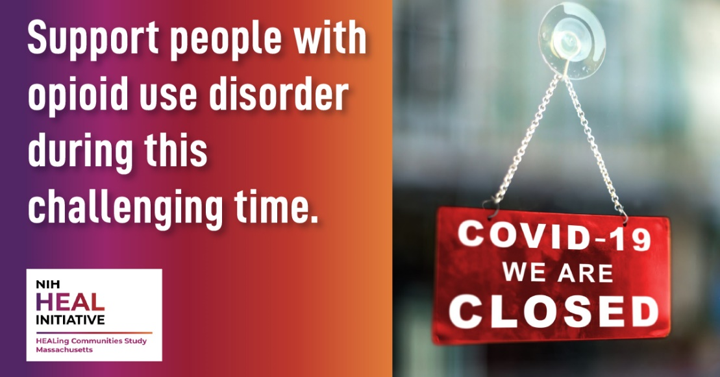

**Post 13:**

Learn how COVID-19 is affecting people with opioid use disorder and in recovery, the justice system, and states across the country. #Covid19

<https://www.drugabuse.gov/drug-topics/comorbidity/covid-19-resources>

<https://www.nih.gov/coronavirus>

<https://www.samhsa.gov/coronavirus>

No image. A preview of the NIDA COVID-19 webpage will auto-populate when the link is used.

**Post 14:**

This is a hard time for our community. If you are struggling in recovery, know that you are not alone. Struggling is not a sign of weakness. Reach out to loved ones or search here for an online recovery support group: [insert state or local resource]. #InThisTogether #StigmaFree

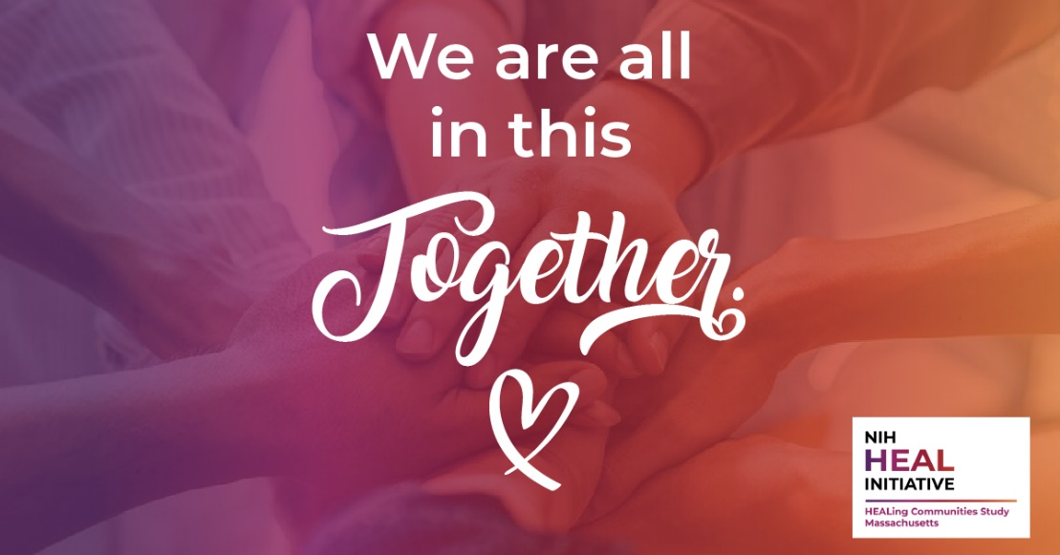

# Partner Engagement Outreach

**PURPOSE:** Send this to partner organizations to secure their support in sharing campaign content.

**Sample Email**

Hi [Director, Communications Director, or other staff name listed on website or social media],

I am working with [insert Coalition name] on the HEALing Communities Study. Led by Boston Medical Center, this project is sponsored by the National Institutes of Health (NIH) and Substance Abuse and Mental Health Services Administration (SAMHSA) and aims to decrease opioid overdose deaths in [insert county name] and 15 other Massachusetts communities by 40 percent. Learn more about our work here: <https://healingcommunitiesstudy.org/sites/massachusetts.html>.

I am writing to ask for your help. From [insert date – date], our coalition is running a campaign to encourage people to seek medications for opioid use disorder (MOUD). Each person has their own path to recovery from opioid use disorder, but research shows that MOUD offers the most effective treatment. MOUD saves lives by decreasing the risk for relapse and overdose death. Also, people who take [FDA-approved medicines](https://www.fda.gov/drugs/information-drug-class/information-about-medication-assisted-treatment-mat), like methadone, buprenorphine, Suboxone® (buprenorphine and naloxone), naltrexone, and Vivitrol® (injectable naltrexone), are more likely to stay in recovery and enjoy healthy, productive lives.

We will be sharing content over the next several weeks and would be so grateful if you could help us get life-saving information out to our community members.

Our communications campaign offers numerous, free materials you can use, including social media graphics. Would you be willing to share some of these resources throughout your communications channels, or have a quick conversation about how you can help our communications campaign?

Best wishes,

[Signature line]

[Insert your coalition’s social media accounts and hyperlink]

**Sample Direct Message (sent through the desired social media platform’s message feature)**

I am working with [insert Coalition name] on the HEALing Communities Study. Led by Boston Medical Center, this project aims to decrease opioid overdose deaths by 40% in [insert community]. We are planning a communication campaign [insert date – date] to encourage people to seek medication treatment for opioid use disorder. Would you be willing to share our content? Thank you, [insert name]

# Sample PSA Scripts

**PURPOSE:** Sample copy to record and distribute a community-oriented public service announcement (PSA) for radio stations at no cost in order to fulfill their obligation to serve the public interest. You can also use the scripts for paid placements.

**NOTE:** Sample scripts are ~30 seconds in length. Edit as needed to meet your placement specifications.

**Option 1**

Are you or a loved one struggling with opioid use disorder? Now is the time to seek help. FDA-approved medications—including methadone, buprenorphine, and naltrexone—are a path to recovery from opioid use disorder. These medications lower the risk of relapse and increase the chances of staying in recovery long-term. Seeking recovery is a brave step, and help is available. Learn more about medications for opioid use disorder available in our community at [Insert HCS community specific link; e.g., HEALTogetherMA.org/Salem]

**Option 2**

Opioid use disorder is a chronic disease that affects many residents in [insert community name]. Like other chronic diseases, it can be treated. Medications like methadone and buprenorphine are the most effective way to save lives by preventing overdose. They also help people stay in treatment and achieve long-term recovery. Learn more about medications for opioid use disorder available in our community at [Insert HCS community specific link; e.g., HEALTogetherMA.org/Salem]

**Option 3**

Are you worried about your use of heroin, fentanyl, or prescription opioids? You are not alone. Thousands in Massachusetts have an opioid use disorder and have questions about seeking and staying in treatment.

But there is hope. Methadone and buprenorphine save lives by preventing overdose. Research shows that these medications are the most effective way to manage opioid cravings, treat the difficult symptoms of withdrawal, and help you stay in treatment long-term.

Learn more about medications for opioid use disorder available in our community at [Insert HCS community specific link; e.g., HEALTogetherMA.org/Salem]

*NOTE: speak website address phonetically (e.g., www dot HealTogetherMA dot org forward slash [insert community name].*

**

